6.G.1 Find the area of right triangles, other triangles, special quadrilaterals, and polygons by composing into rectangles or decomposing into triangles and other shapes; apply these techniques in the context of solving real-world and mathematical problems.

Perimeter – add all sides
Perimeter measures the outside (units)

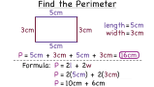

Area – measures the inside (units²)

Students decompose shapes into rectangles and triangles to determine the area.
Rectangle - L x W Triangle – ½ x b x h
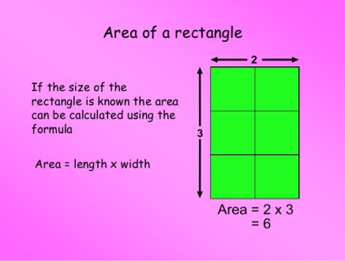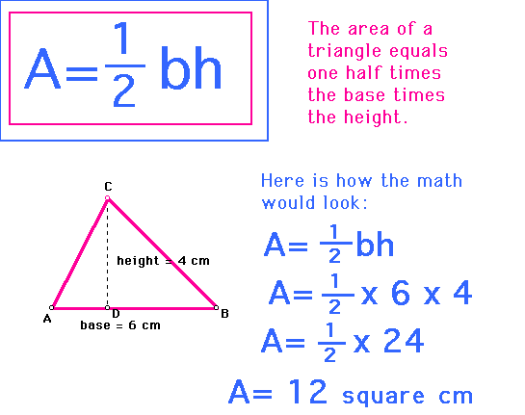

Student Notes:
Example: Find the area of a right triangle with a base length of three units, a height of four units, and a hypotenuse of 5.
Solution: Students understand that the hypotenuse is the longest side of a right triangle. The base and height would form the 90°angle and would be used to find the area using: A = ½ bh A = ½ (3 units)(4 units) A = ½ 12 units2 A = 6 units2

Example: A rectangle measures 3 inches by 4 inches. If the lengths of each side double, what is the effect on the area?
Solution: The new rectangle would have side lengths of 6 inches and 8 inches. The area of the original rectangle was 12 inches² . The area of the new rectangle is 48 inches² . The area increased 4 times (quadrupled). Students may also create a drawing to show this visually.

Squares - S x S
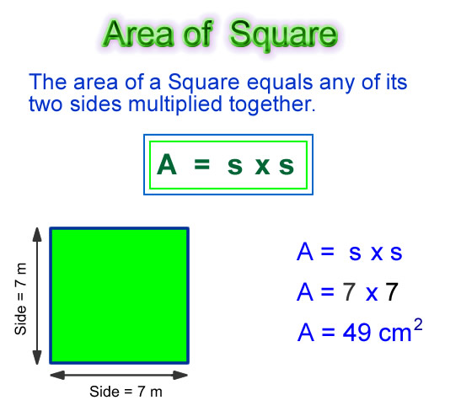

Parallelograms – b x h
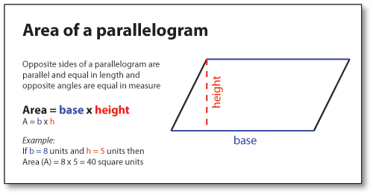
Decompose/Compose
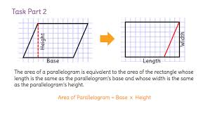

Student Notes:
Example : The lengths of the sides of a bulletin board are 4 feet by 3 feet. How many index cards measuring 4 inches by 6 inches would be needed to cover the board?
Solution: Change the dimensions of the bulletin board to inches (4 feet = 48 inches; 3 feet = 36 inches). The area of the board would be 48 inches x 36 inches or 1728 inches² . The area of one index card is 12 inches² . Divide 1728 inches² by 24 inches² to get the number of index cards. 72 index cards would be needed.

Rhombus – b x h or d₁ x d₂ Kites - d₁ x d₂
2 2
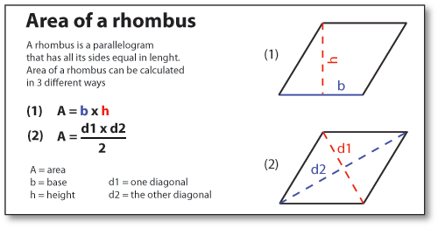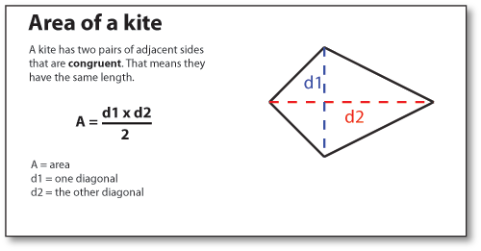
Decompose/Compose (Triangles)
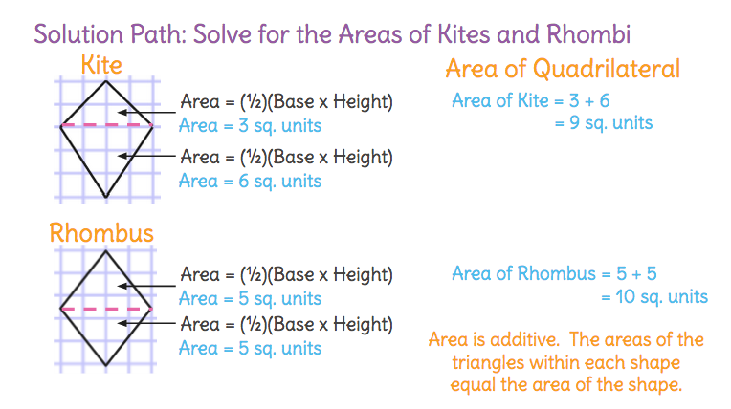
Trapezoids - ½ h (a + b)
Trapezoids can be decomposed into triangles and rectangles (see figures below). Using the trapezoid’s dimensions, the area of the individual triangle(s) and rectangle can be found and then added together.

Irregular Polygon – cut into rectangles/triangles and add the areas together
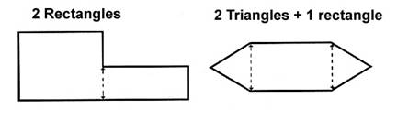

Q: Find the area of the trapezoid shown below using the formulas for rectangles and triangles.
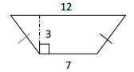
Solution: The trapezoid could be decomposed into a rectangle with a length of 7 units and a height of 3 units. The area of the rectangle would be 21units². The triangles on each side would have the same area. The height of the triangles is 3 units. After taking away the middle rectangle’s base length, there is a total of 5 units remaining for both of the side triangles. The base length of each triangle is half of 5. The base of each triangle is 2.5 units. The area of one triangle would be ½ (2.5 units)(3 units) or 3.75 units² . Using this information, the area of the trapezoid would be: 21 units² + 3.75 units² +3.75 + units² = 28.5 units²
6.G.2 Find the volume of a right rectangular prism with fractional edge lengths by packing it with unit cubes of the appropriate unit fraction edge lengths, and show that the volume is the same as would be found by multiplying the edge lengths of the prism. Apply the formulas V = l w h and V = b h to find volumes of right rectangular prisms with fractional edge lengths in the context of solving real-world and mathematical problems.

Student Notes:

Volume = L x W x H (units³)
Q: What does volume mean?
A: The number of small units that fit in a larger object.
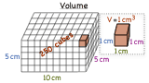

Example #1:
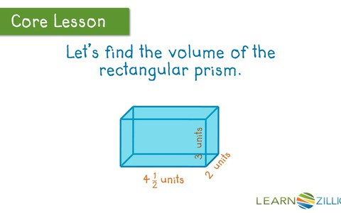
Answer: 4 ½ x 2 x 3 = 27 units³

Student Notes:

Example #2:
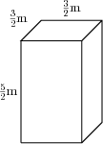
Answer: 3/2 x 3/2 x 5/2 = 45/8 = 5 5/8 m³
6.G.3 Draw polygons in the coordinate plane given coordinates for the vertices; use coordinates to find the length of a side joining points with the same first coordinate or the same second coordinate. Apply these techniques in the context of solving real-world and mathematical problems.

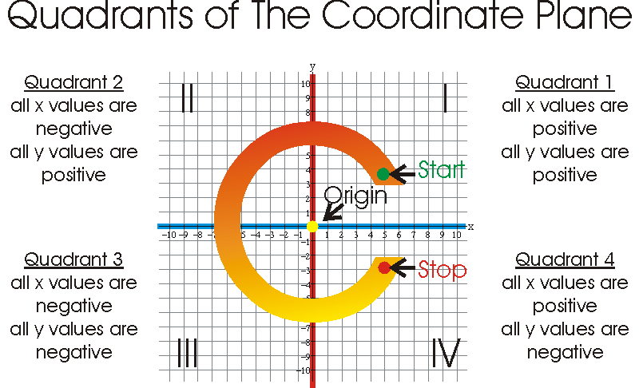
Sample Problem:
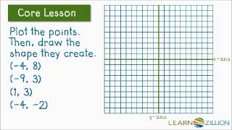
Student Notes:
Example 1: If the points on the coordinate plane below are the three vertices of a rectangle, what are the coordinates of the fourth vertex? How do you know? What are the length and width of the rectangle? Find the area and the perimeter of the rectangle.
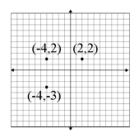Example 2: On a map, the library is located at (-2, 2), the city hall building is located at (0,2), and the high school is located at (0,0). Represent the locations as points on a coordinate grid with a unit of 1 mile.
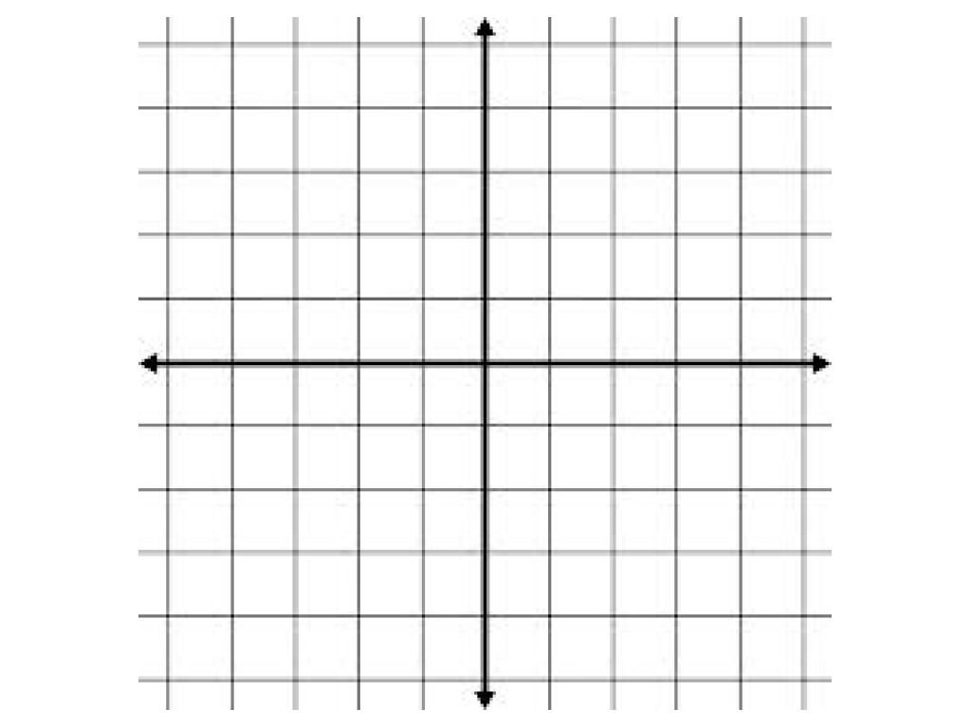1. What is the distance from the library to the city hall building? The distance from the city hall building to the high school? How do you know?
2. What shape does connecting the three locations form? The city council is planning to place a city park in this area. How large is the area of the planned park?
6.G.4 Represent three-dimensional figures using nets made up of rectangles and triangles, and use the nets to find the surface area of these figures. Apply these techniques in the context of solving real-world and mathematical problems.

Surface Area – the sum of all areas in a 3D object
Nets – an unfolded 3D model that is turned into a 2D image. Used to find the surface area of 3D objects.

Rectangular Prism
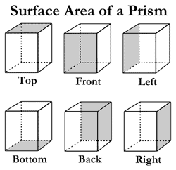

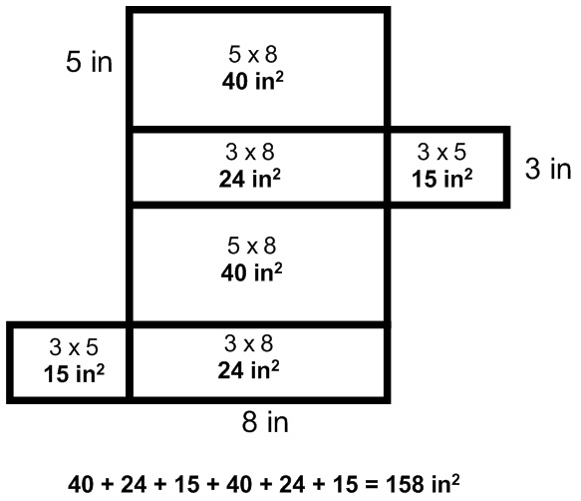

Triangular Prism
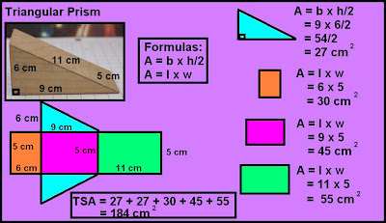

Square/Rectangular Pyramid
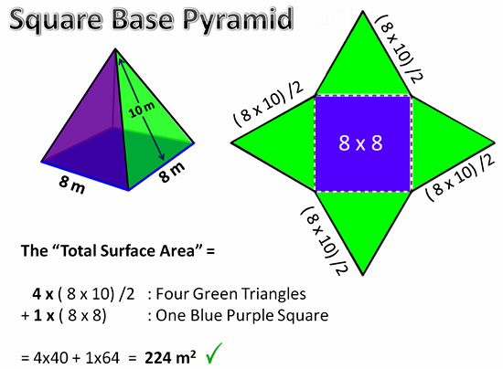

Triangular Pyramid
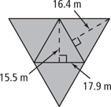
Student Notes:

