Business Items  (10 minutes) | Step 1 - Spiral Review  Complete the daily Spiral Review problems and be sure that you include your work. | Step 2 - Warm Up  Process the Error Analysis question independently. Talk to your shoulder partner about the misconception and what the correct answer should be. |  |  |  |  |  | Step 3 - Math Talks – Homework Discussion  Use the answer keys, if provided, to check your homework. With your shoulder partner, discuss the problem(s) that you still don’t grasp.
Engage  (10 minutes) | Math Talks – Day #1  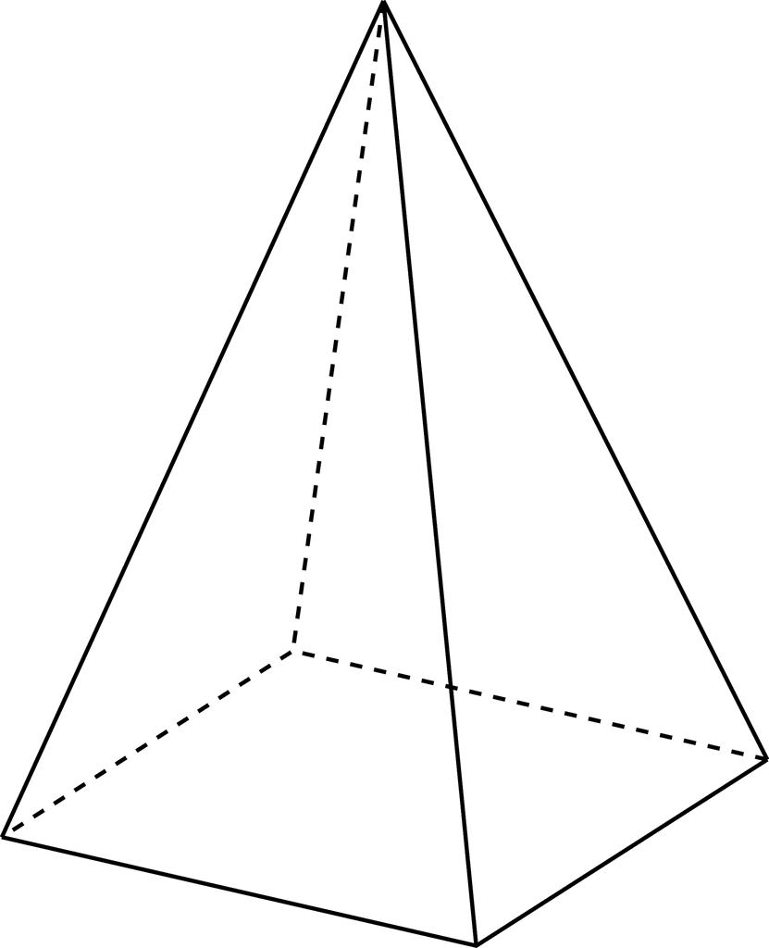  In teams of two, sketch a quick picture of a net for the image of the square pyramid. |  |  |  | Math Talks – Day #2  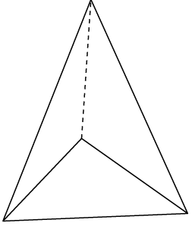  In teams of two, sketch a quick picture of a net for the image of the triangular pyramid.
Lesson  (20 minutes) | Coaching Points/Update Note Guide  Pyramids make a point at the top. The base determines if it’s a square pyramid or a triangular pyramid.  Square Pyramids  - 5 faces – 1 square base, 4 identical triangles  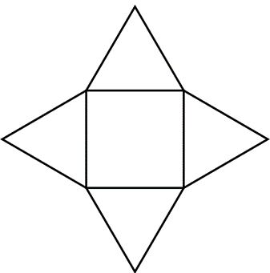  Triangular Pyramids  - 4 faces – 1 triangular base, 3 triangular sides  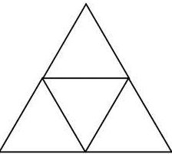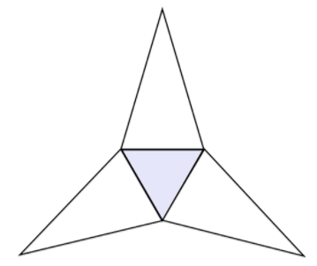 |  |  | Free Choice | Choice 1 – Watch this YouTube video to see how to find the surface area of square pyramids. |  |  |  | Choice 2 –.Watch this YouTube video to see how to use nets to calculate the surface area of square pyramids.
 |  |  |  |  | Choice 3 – Watch this YouTube video to see how to find the surface area of triangular pyramids. |  |  |  | Choice 4 – Watch this YouTube video to see how to use nets to calculate the surface area of triangular pyramids.
Practice  (15-20 minutes) | Classwork #1 – Square Pyramids  With a shoulder partner, pick 2-4 problems to solve. Before moving to another question, be sure that you and your partner share out your answers and agree. Use the answer key to settle disputes. |  |  |  |  | Classwork #2 – Triangular Pyramids  With a shoulder partner, pick 2-3 problems to solve. Before moving to another question, be sure that you and your partner share out your answers and agree. Use the answer key to settle disputes.
HW | Homework #1:  Click on the link to access tonight’s homework on finding the surface area of square pyramids. Pick any 5 to solve and use the answer key to check your work before class. |  |  |  |  | Homework #2:  Click on the link to access tonight’s homework on finding the surface area of triangular pyramids. Pick any 5 to solve and use the answer key to check your work before class.
Remediation | Let Your Data Drive Your Decisions  Rate your level of understanding with finding nets and finding the surface area of pyramids. If you feel weak at all, select a remediation tool from the choices provided. The additional help will pay off, as you work towards content mastery. |  | Free Choice | Choice A – LearnZillion  Take a few minutes to remediate with this LearnZillion lesson on finding the surface area of square pyramids. |  |  | Choice B – Geometry 3D  Review and explore pyramids using the interactive Geometry 3D site. |  |  | Choice C – Tutorial  Get another look at square and triangular pyramids with this online tutorial.
 |  |  |  | Choice D – Math Interactives  Explore nets of pyramids using the Math Interactive site. |  |  | Choice E – Online Tutorial  View the online tutorial on nets and surface area from Texas Gateway.  . |  |  | Choice F – Help Desk  Check in with the teacher for some quick, low key help. Be sure to bring some work samples to share. This will allow for a quick diagnosis.

