Business Items  (10 minutes) | Step 1 - Spiral Review  Complete the daily Spiral Review problems and be sure that you include your work. | Step 2 - Warm Up  Process the Error Analysis question independently. Talk to your shoulder partner about the misconception and what the correct answer should be. |  |  |  |  |  | Step 3 - Math Talks – Homework Discussion  Use the answer keys, if provided, to check your homework. With your shoulder partner, discuss the problem(s) that you still don’t grasp.
Engage  (10 minutes) | Day #1 – Nets and Surface Area of Rectangular Prisms  Watch this video to see what shapes make up a rectangular prism. Turn to your shoulder partner and share the number of faces you see and what shapes make up each face. |  |  |  |  | Day #2 –Nets and Surface Area of Triangular Prisms  Watch this video to see what shapes make up a triangular prism. Turn to your shoulder partner and share the number of faces you see and what shapes make up each face.
Lesson  (20 minutes) | Coaching Points/Update Note Guide  Reactangular Prisms/Cubes  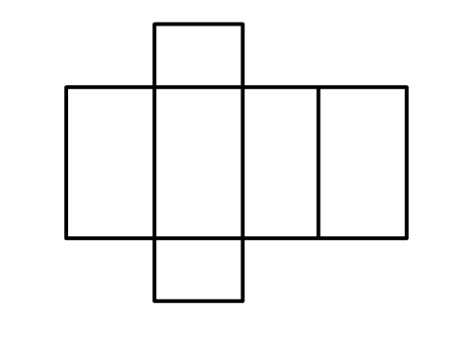  - 6 faces = 6 areas  - Front/back  - Top/bottom  - Left/right  Triangular Prisms  - 5 faces = 5 areas  - 2 identical triangles, 3 rectangles  - Type of triangle tells you how many of the areas are identical  - Scalene – 0 same  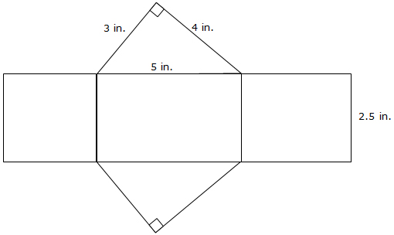  - Isosceles – 2 same  - Equilateral - 3 same |  |  | Free Choice | Choice 1 – Watch this video for a tutorial on finding the surface area of a cube. |  |  |  | Choice 2 –. Watch this video for a tutorial on finding the surface area of a rectangular prism.
 |  |  |  |  | Choice 3 – Watch this video for a tutorial on finding the surface area of a triangular prism. |  |  |  | Choice 4 – Learn and practice with nets as you find the surface area of rectangular prisms using Glencoe’s interactive site.
Practice  (15-20 minutes) | Math Talks - Classwork #1  Solve the 4 classwork problems on surface area of rectangular prisms. With your shoulder partner, discuss your results. You must agree on the answer before moving on. |  |  |  |  | Math Talks - Classwork #2  Solve 2-4 of the classwork problems on finding the surface area of triangular prisms. With your shoulder partner, discuss your results. You must agree on the answer before moving on. Let the answer key settle any disputes.
HW | Homework #1:  HW #1 contains 10 problems that will require you to find the surface area of rectangular prisms. Pick any 7 to solve and check your answers with the key provided. |  |  |  |  | Homework #2:  Open HW #2 to access the 6 problems that will require you to find the surface area of triangular prisms. Pick any 5 to solve and check with the answer key provided.
Remediation | Let Your Data Drive Your Decisions  Rate your level of understanding with finding nets and finding the surface area of prisms. If you feel weak at all, select a remediation tool from the choices provided. The additional help will pay off, as you work towards content mastery. |  | Free Choice | Choice A – Interactive  Visit Interactives Geometry 3D to learn more about nets and calculating the surface area or rectangular prisms. |  |  | Choice B – Math Arcade  Practice finding the surface area of rectangular prisms with this 10 question practice game. |  |  | Choice C – Video  Watch this video to see a real world example of how and why to calculate the surface area of a rectangular prisms.
 |  |  |  | Choice D – Quizizz  Get some additional practice using Quizizz. Search “mmcdowel” and find the game titled 6.G.4 – Surface Area of Rectangular Prisms. |  |  | Choice E – Quizizz  .  Get some additional practice using Quizizz. Search “mmcdowel” and find the game titled 6.G.4 – Surface Area of Triangular Prisms. |  |  | Choice F – Help Desk  Check in with the teacher for some quick, low key help. Be sure to bring some work samples to share. This will allow for a quick diagnosis.

