**6.G.3 Plotting Polygons Warm-Up**

**Instructions:** Work on the following problem individually.

1. Plot the points below on the coordinate plane.



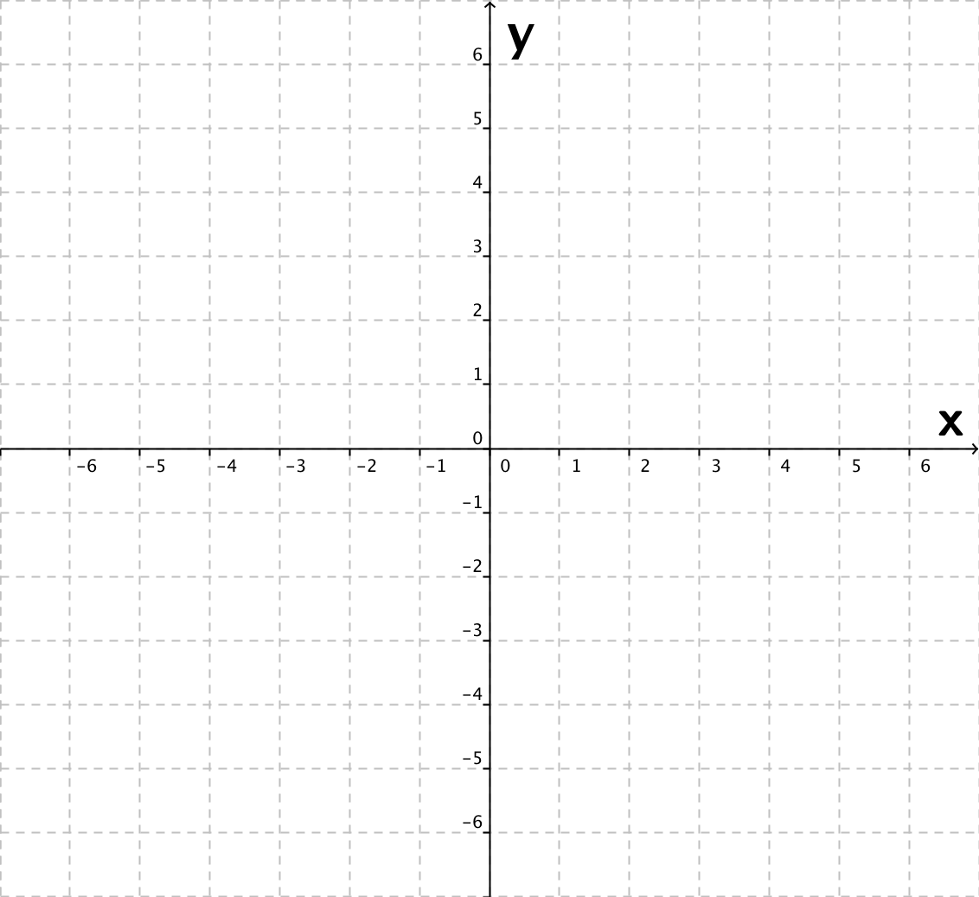

**6.G.3 Plotting Polygons Warm-Up (version 2)**

**Instructions:** Work on the following problem individually.

1. Draw a coordinate plane and plot the points below on your coordinate plane.





**6.G.3 Plotting Polygons Warm-Up (Answer Key)**

**Instructions:** Work on the following problem individually.

1. Plot the points below on the coordinate plane.



