6.G.3 – Polygons/Coordinate Plane Name ____________________________
1. If the points on the coordinate plane below are the three vertices of a rectangle.
(a) What are the coordinates of the fourth vertex? How do you know?
(b) What are the length and the width of the rectangle?
(c) What are the area and perimeter of the rectangle?
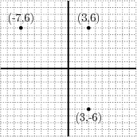
2. On a map, the theater is located at (-4,-4), the courthouse is located at (2, 9), and the train station is located at (2,-4). Represent the locations as points on a coordinate grid with a unit of 1 km.
(a) What is the distance from the the theater to the train station? The distance from the train station to the courthouse? How do you know?
(b) What shape does connecting the three locations form?
(c) The mayor is planning on constructing a public plaza in this area. What is the area of the planned plaza?
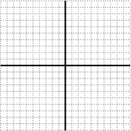

3. The sides of a rectangle in the coordinate plane are parallel to the axes. Two of the vertices of the rectangle are $(3,-2)$ and $(-4,-7)$. Find coordinates for the other two vertices. Find the area of the rectangle.

