6.G.3 Counting Distance/Coordinate Plane (Homework)

In class we have learned how to measure the length of horizontal and vertical sides using two different methods. In this activity we will use both method while exploring line segments that are not entirely in the first quadrant.

1. Use the following line segment to answer all the parts of this question.
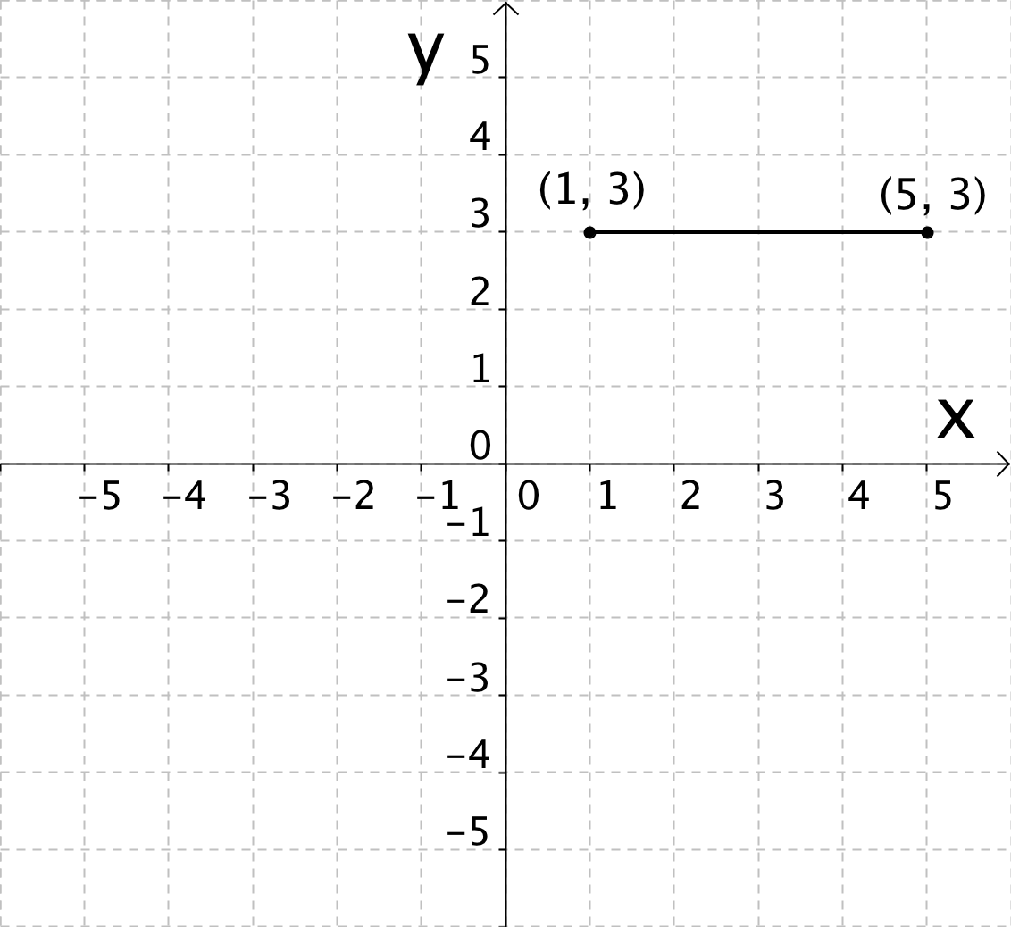
- Write the calculation you would use to find the length of the following line segment if you were using Method #2: Calculating Using Coordinates. Do NOT solve the calculation yet; just write it down.

- Use Method #1: Counting on the Coordinate Plane to find the length of the line segment.

- Solve the calculation you wrote in part A.

- Does you answer for the length of the line segment in part C (using Method #2) match the answer in part B (using Method #1)?

2. What is 5 – (–2) equal to? If you don’t know, do you have any guess of how you might figure it out?

3. Use the following line segment to answer all the parts of this question.
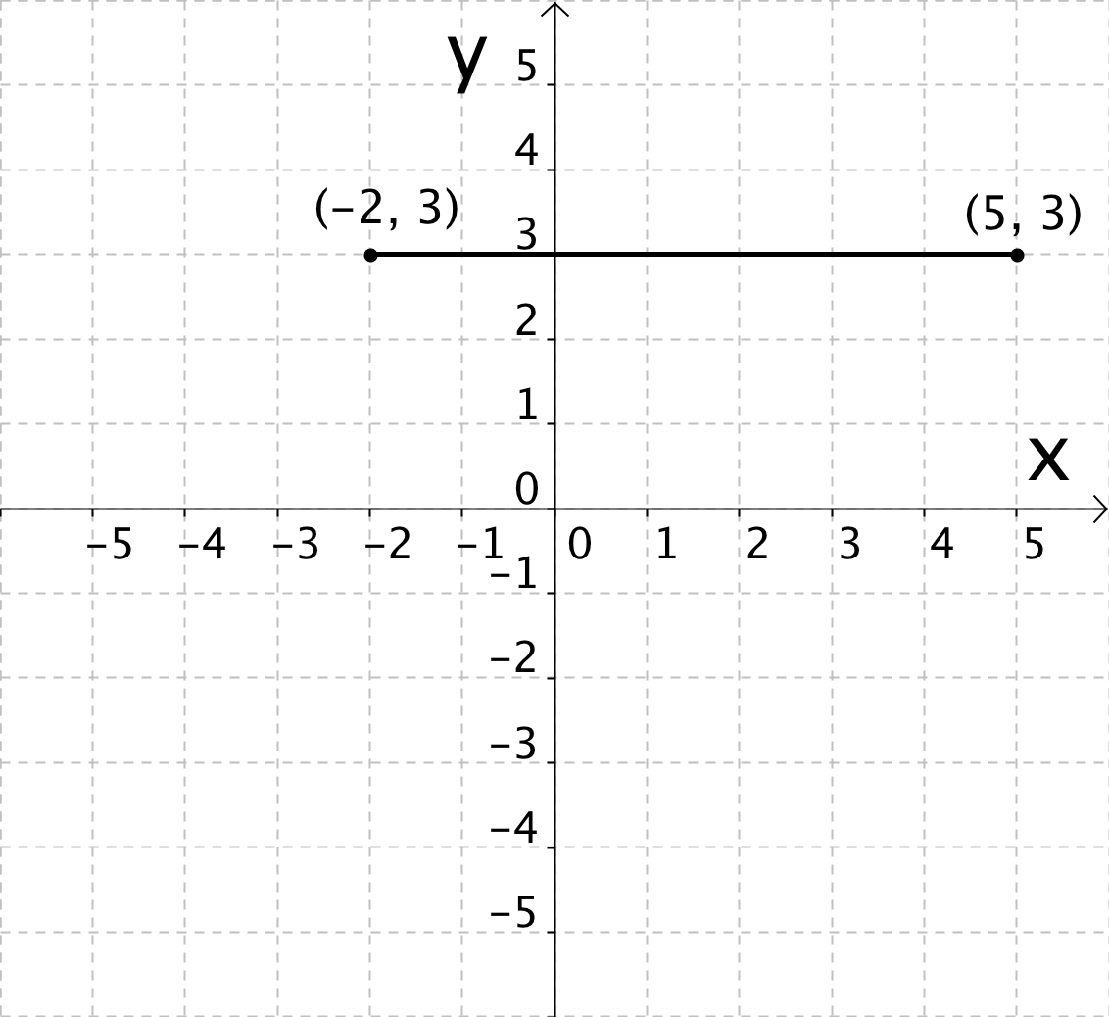
- Write the calculation you would use to find the length of the following line segment if you were using Method #2: Calculating Using Coordinates. Do NOT solve the calculation yet; just write it down.

- Use Method #1: Counting on the Coordinate Plane to find the length of the line segment.

- Set your calculation in part A equal to the answer you got in part B.

- What is 5 – (–2) equal to?

4. What is –1 – (–4) equal to? If you don’t know, do you have any guess of how you might figure it out?

5. Use the following line segment to answer all the parts of this question.
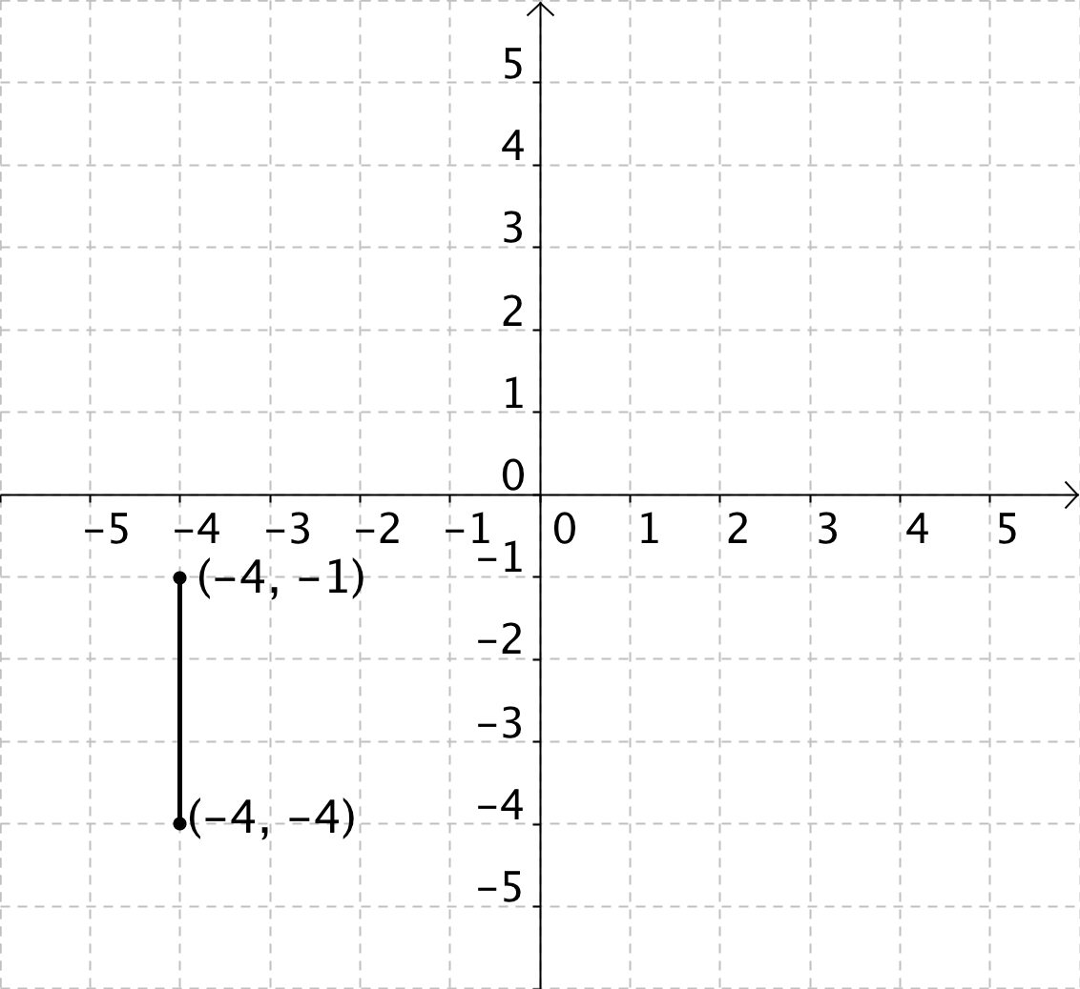
- Write the calculation you would use to find the length of the following line segment if you were using Method #2: Calculating Using Coordinates. Do NOT solve the calculation yet; just write it down.

- Use Method #1: Counting on the Coordinate Plane to find the length of the line segment.

- Set your calculation in part A equal to the answer you got in part B.

- What is –1 – (–4) equal to?

6. For each of the following subtraction problems do the following:
- Draw a line segment that will help you solve the problem.
- Label the endpoints with their coordinates.
- Solve the subtraction problem using the line segment.
- Explain how you solved the subtraction problem.

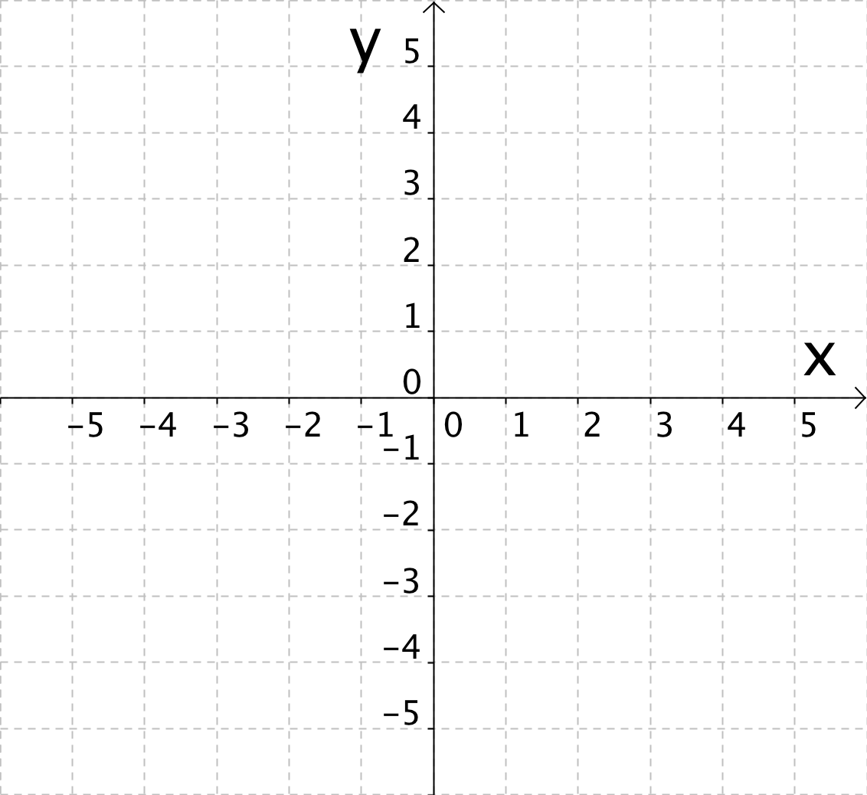 | 3 – (–1) = _________  Explanation:
–1 – (–3) = _________

Explanation:
0 – (–4) = _________

Explanation:

Plotting Polygons 6.G.3 (Homework #2 with Answer Key)

In class we have learned how to measure the length of horizontal and vertical sides using two different methods. In this activity we will use both method while exploring line segments that are not entirely in the first quadrant.

1. Use the following line segment to answer all the parts of this question.
- Write the calculation you would use to find the length of the following line segment if you were using Method #2: Calculating Using Coordinates. Do NOT solve the calculation yet; just write it down.

5 – 1

- Use Method #1: Counting on the Coordinate Plane to find the length of the line segment.

4 units

- Solve the calculation you wrote in part A.

5 – 1 = 4

- Does you answer for the length of the line segment in part C (using Method #2) match the answer in part B (using Method #1)?

Yes! Both methods gave me an answer of 4.

Note to teachers: The point of problem 1 is to reinforce that counting on the coordinate plane and calculating using the coordinates are both viable methods that will give the SAME result for any given line segment length.

2. What is 5 – (–2) equal to? If you don’t know, do you have any guess of how you might figure it out?

I don’t know! I have no clue! Or perhaps students will take a guess like 3.

Note to teachers: At this point students have not studied how to add/subtract integers which is a 7th grade content standard. However questions 2–5 are all meant to help students learn to use line segments on the coordinate plane to solve subtraction problems involving integers. By question 6 students are hopefully able to draw their own line segments to solve subtraction problems involving integers.

3. Use the following line segment to answer all the parts of this question.
- Write the calculation you would use to find the length of the following line segment if you were using Method #2: Calculating Using Coordinates. Do NOT solve the calculation yet; just write it down.

5 – (–2)

- Use Method #1: Counting on the Coordinate Plane to find the length of the line segment.

7 units

- Set your calculation in part A equal to the answer you got in part B.

5 – (–2) = 7 units

- What is 5 – (–2) equal to?

5 – (–2) = 7

4. What is –1 – (–4) equal to? If you don’t know, do you have any guess of how you might figure it out?

Most students will say I don’t know. See the note in question 2.

5. Use the following line segment to answer all the parts of this question.
- Write the calculation you would use to find the length of the following line segment if you were using Method #2: Calculating Using Coordinates. Do NOT solve the calculation yet; just write it down.

–1 – (–4)

- Use Method #1: Counting on the Coordinate Plane to find the length of the line segment.

3 units

- Set your calculation in part A equal to the answer you got in part B.

–1 – (–4) = 3 units

- What is –1 – (–4) equal to?

–1 – (–4) = 3

6. For each of the following subtraction problems do the following:
- Draw a line segment that will help you solve the problem.
- Label the endpoints with their coordinates.
- Solve the subtraction problem using the line segment.
- Explain how you solved the subtraction problem.

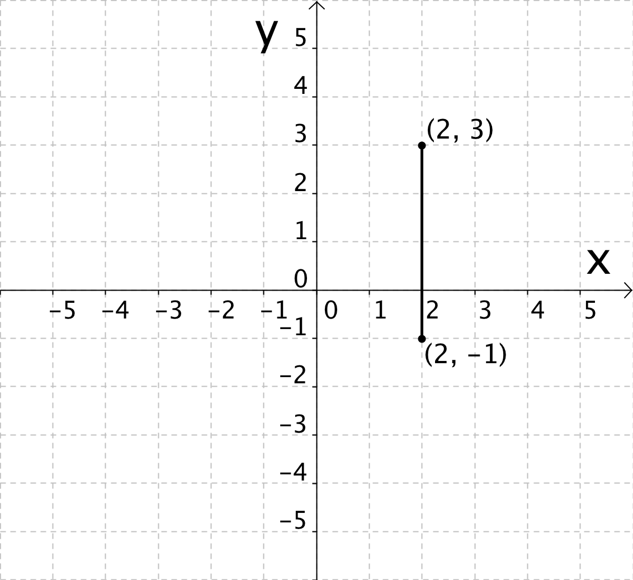 | 3 – (–1) = 4 units  Explanation:  Draw a line segment that has x-coordinate or y-coordinates at 3 and –1. Then count how long the line segment is. Line segments that students will draw may vary.
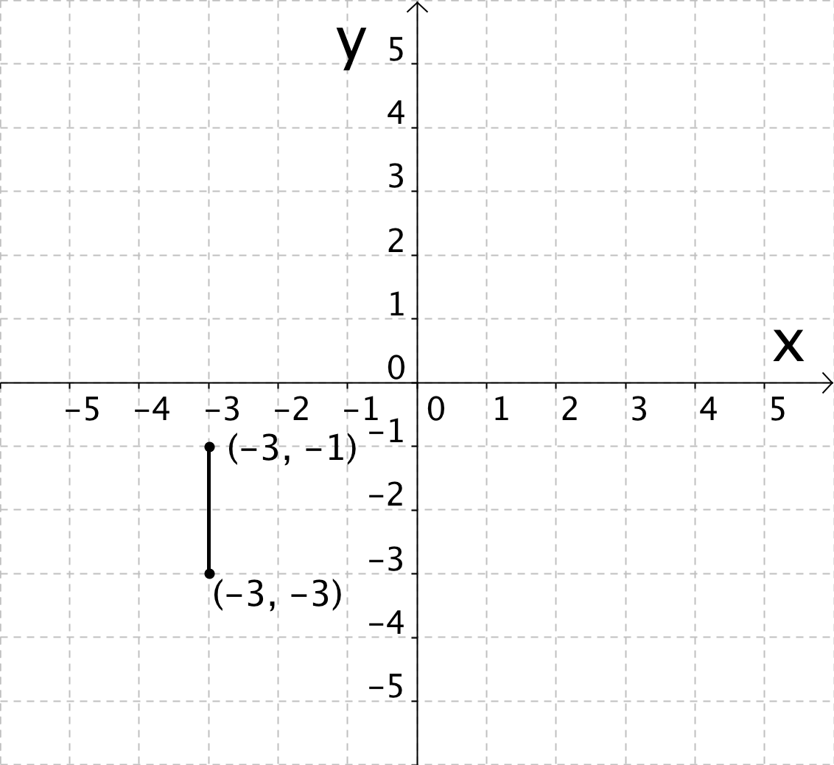 | –1 – (–3) = 2 units  Explanation:  Draw a line segment that has x-coordinate or y-coordinates at –1 and –3. Then count how long the line segment is. Line segments that students will draw may vary.
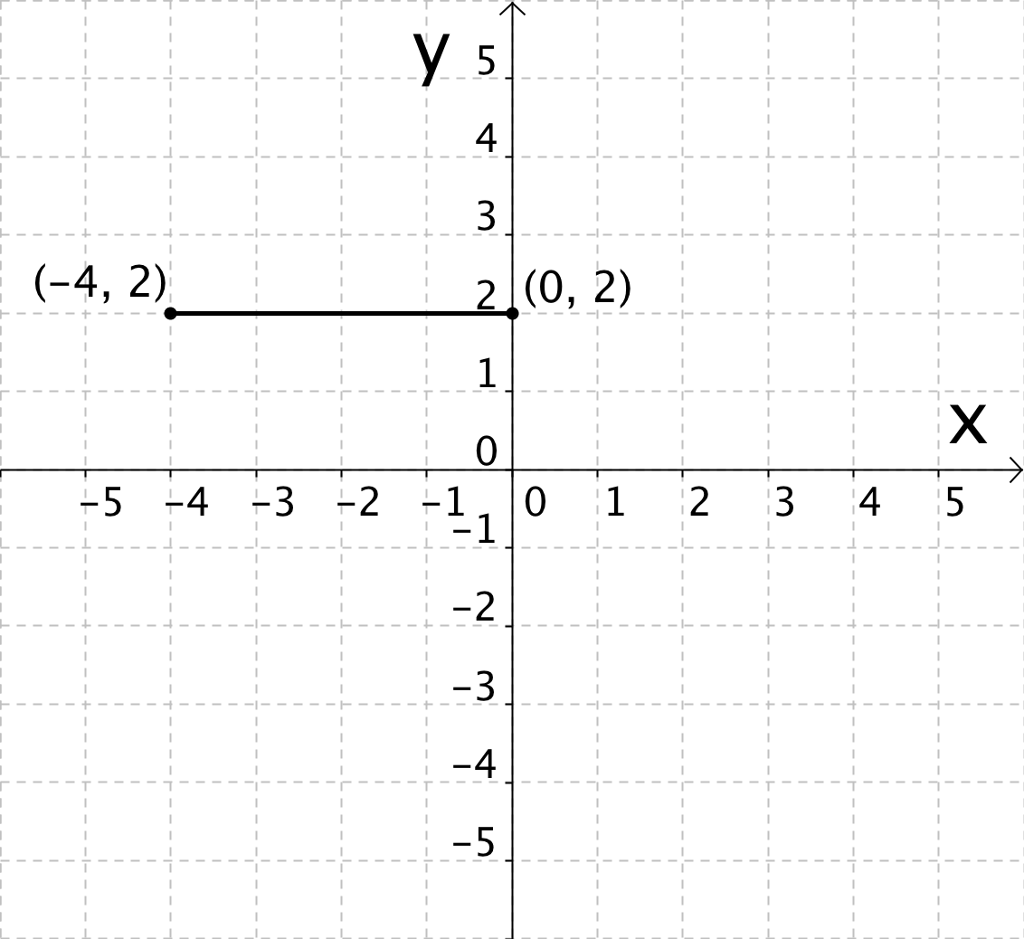 | 0 – (–4) = 4 units  Explanation:  Draw a line segment that has x-coordinate or y-coordinates at 0 and –4. Then count how long the line segment is. Line segments that students will draw may vary.

