6.G.3 Counting Distance/Coordinate Plane (Classwork)

Instructions: Work on the following problems individually.

1. For the polygon below, calculate the length of each side using Method #2: Calculating Using Coordinates. Make sure to show the calculation you used to find the length next to each side. At the end, check by using Method #1: Counting on the Coordinate Plane.
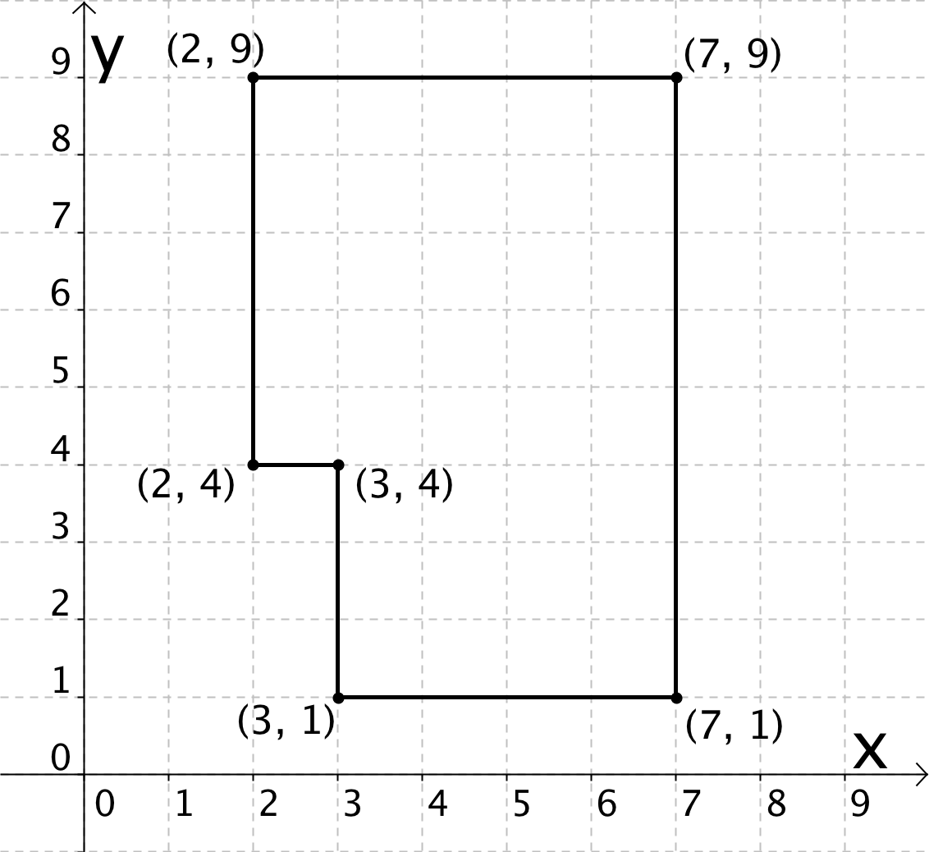

2. What do all points that lie on the same horizontal line have in common? What do all points that lie on the same vertical line have in common?

3. Do the following for the set of points below:
- Sketch a picture of the polygon with vertices at the give points.
- Label the vertices with their coordinates.
- Find the length of each side using Method #2: Calculating Using Coordinates. Show your calculation.
- Calculate the perimeter of each polygon.
Perimeter is _________________________________. | 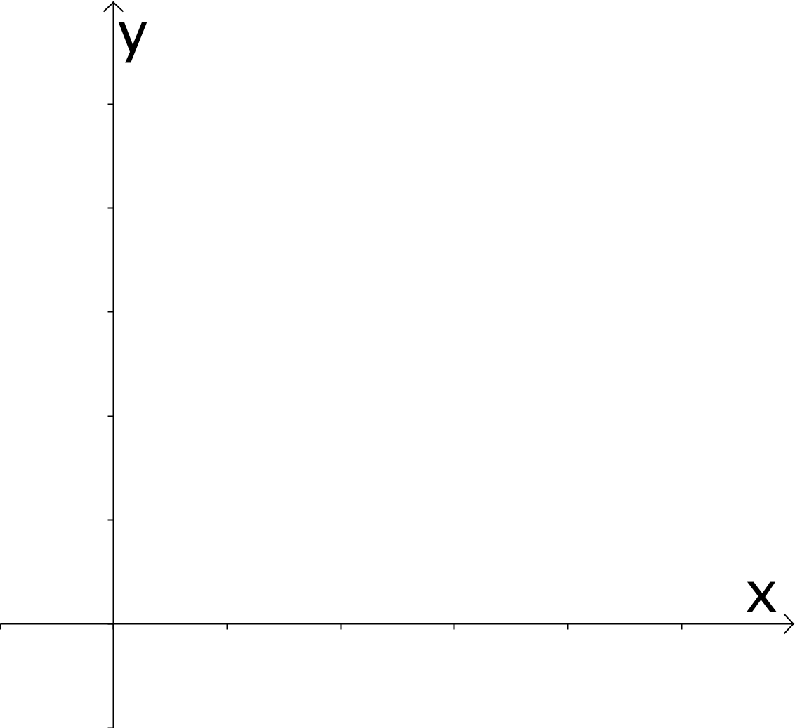
Plotting Polygons 6.G.3 (Answer Key)

Instructions: Work on the following problems individually.

1. For the polygon below, calculate the length of each side using Method #2: Calculating Using Coordinates. Make sure to show the calculation you used to find the length next to each side. At the end, check by using Method #1: Counting on the Coordinate Plane.
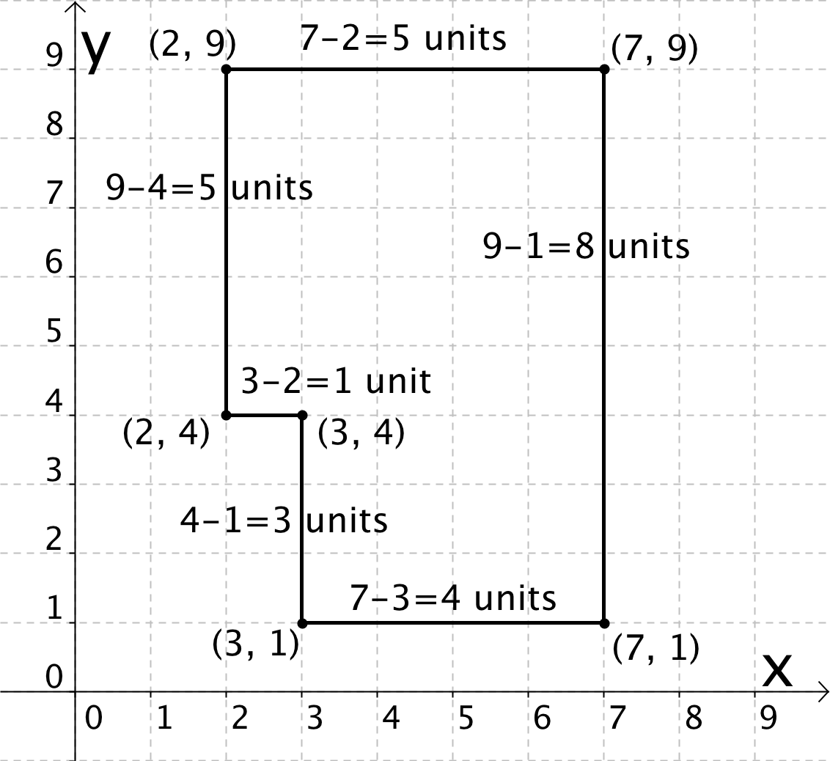
2. What do all points that lie on the same horizontal line have in common? What do all points that lie on the same vertical line have in common?

All points on the same horizontal line have the same y-coordinate since they are the same distance away from the x-axis. The horizontal line segment must be parallel to the x-axis.
All points on the same vertical line have the same x-coordinate since they are the same distance away from the y-axis. The vertical line segment must be parallel to the y-axis.

3. Do the following for the set of points below:
- Sketch a picture of the polygon with vertices at the give points.
- Label the vertices with their coordinates.
- Find the length of each side using Method #2: Calculating Using Coordinates. Show your calculation.
- Calculate the perimeter of each polygon.
Perimeter is 40 units. | 