Counting Distance on the Coordinate Plane - 6.G.3 Lesson Launch

Measuring Horizontal Line Segments:

Method #1: Counting on the Coordinate Plane | Method #2 | Check
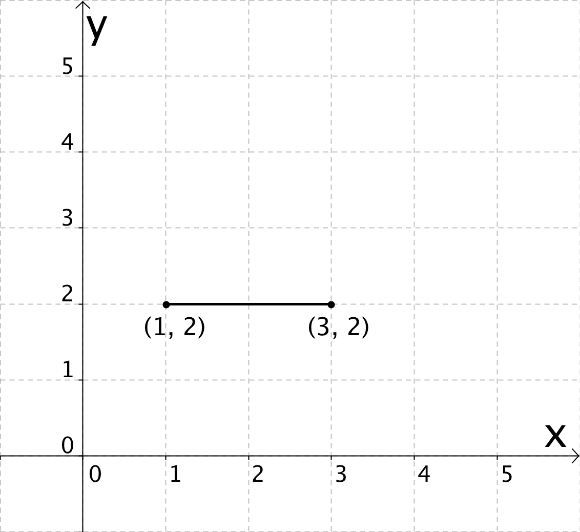
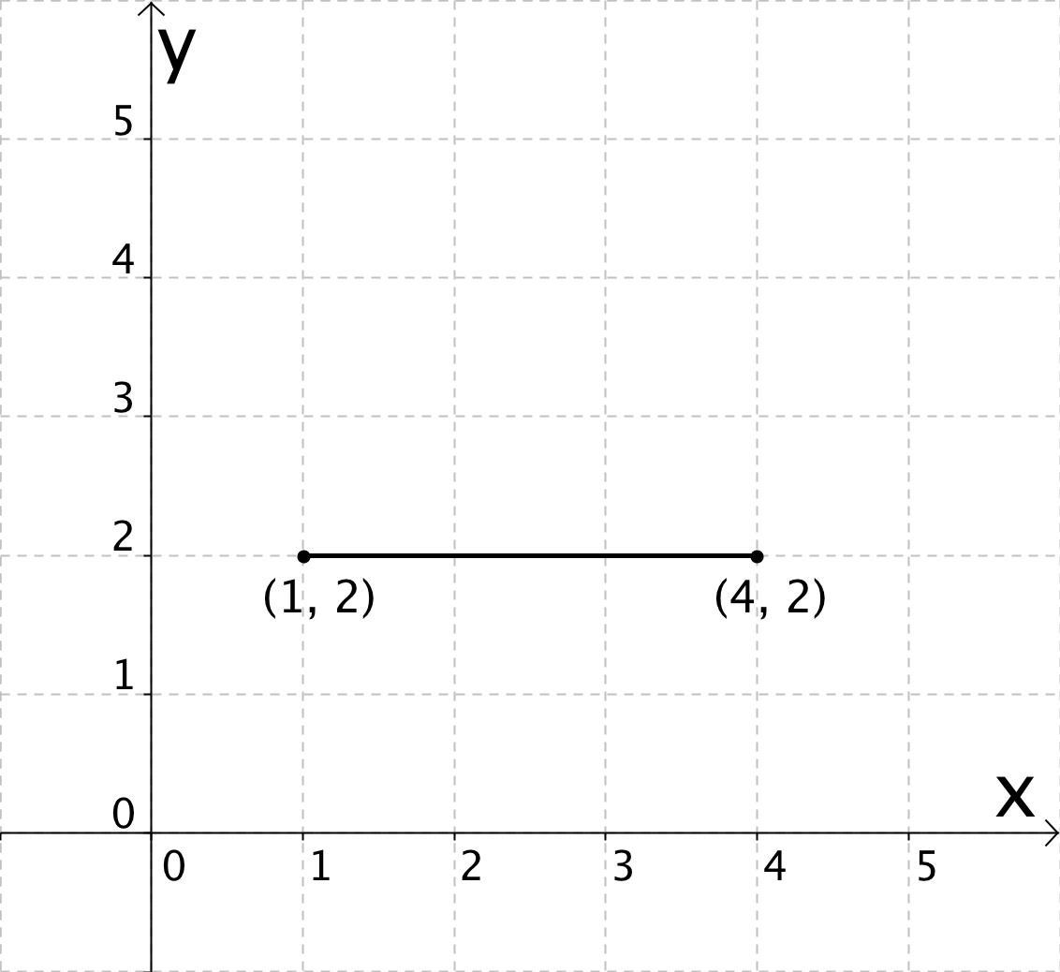
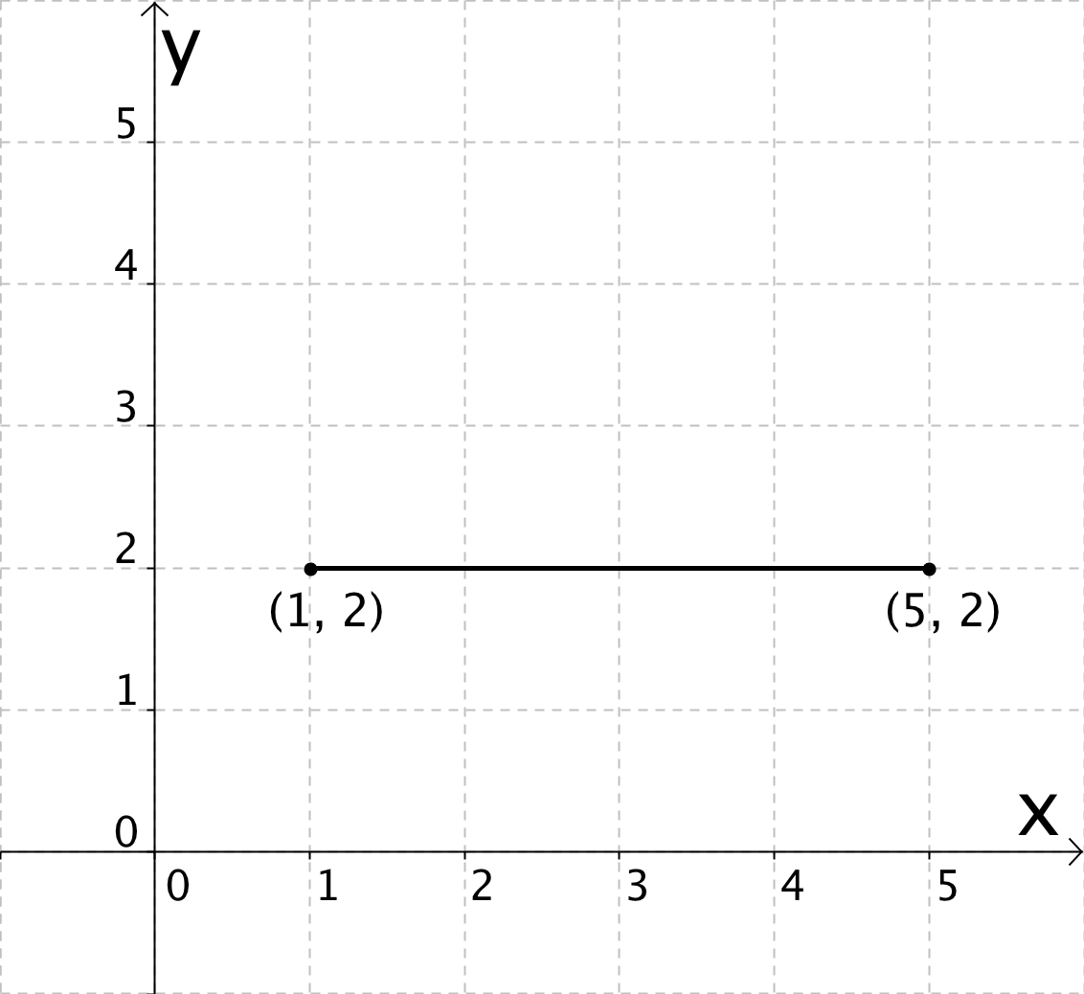

Questions:

1. What coordinate stays the same in each of the three examples?

2. What coordinate changes in each of the three examples?

3. What is the relationship between the coordinate that changes and the length of the line segment?

Measuring Vertical Line Segments:

Method #1: Counting on the Coordinate Plane | Method #2 | Check
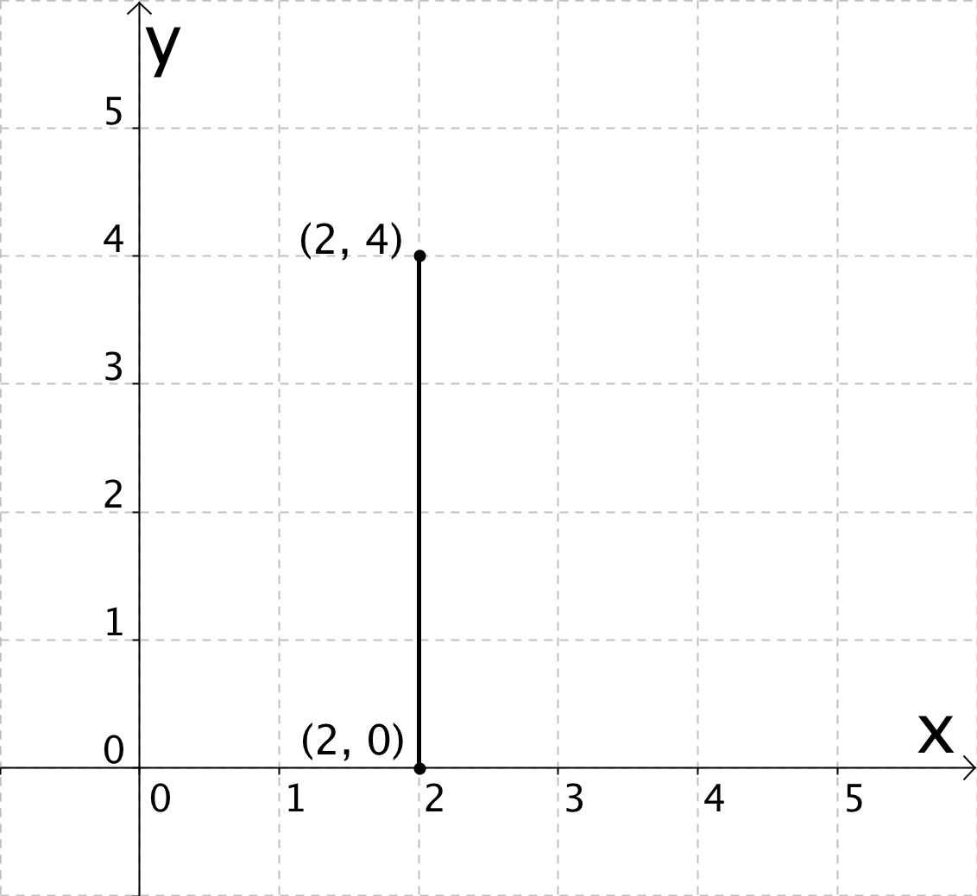
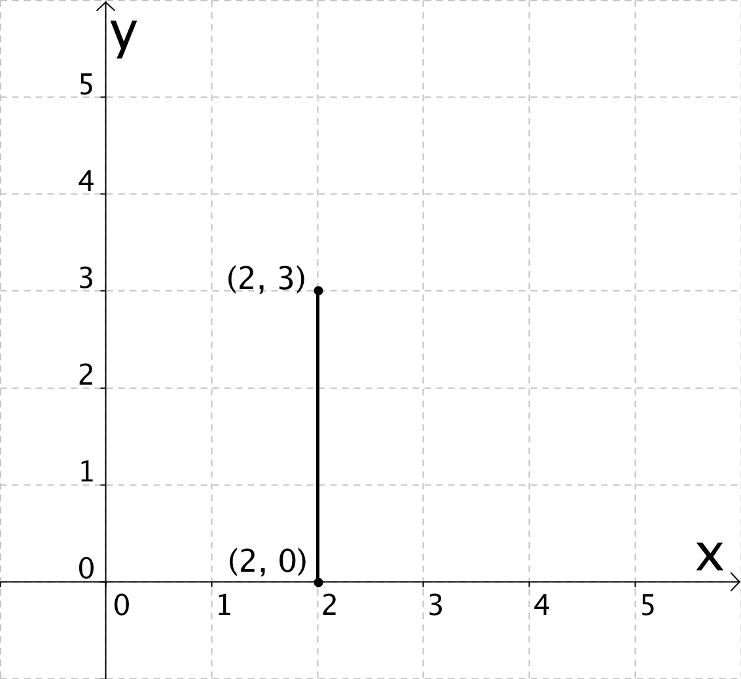
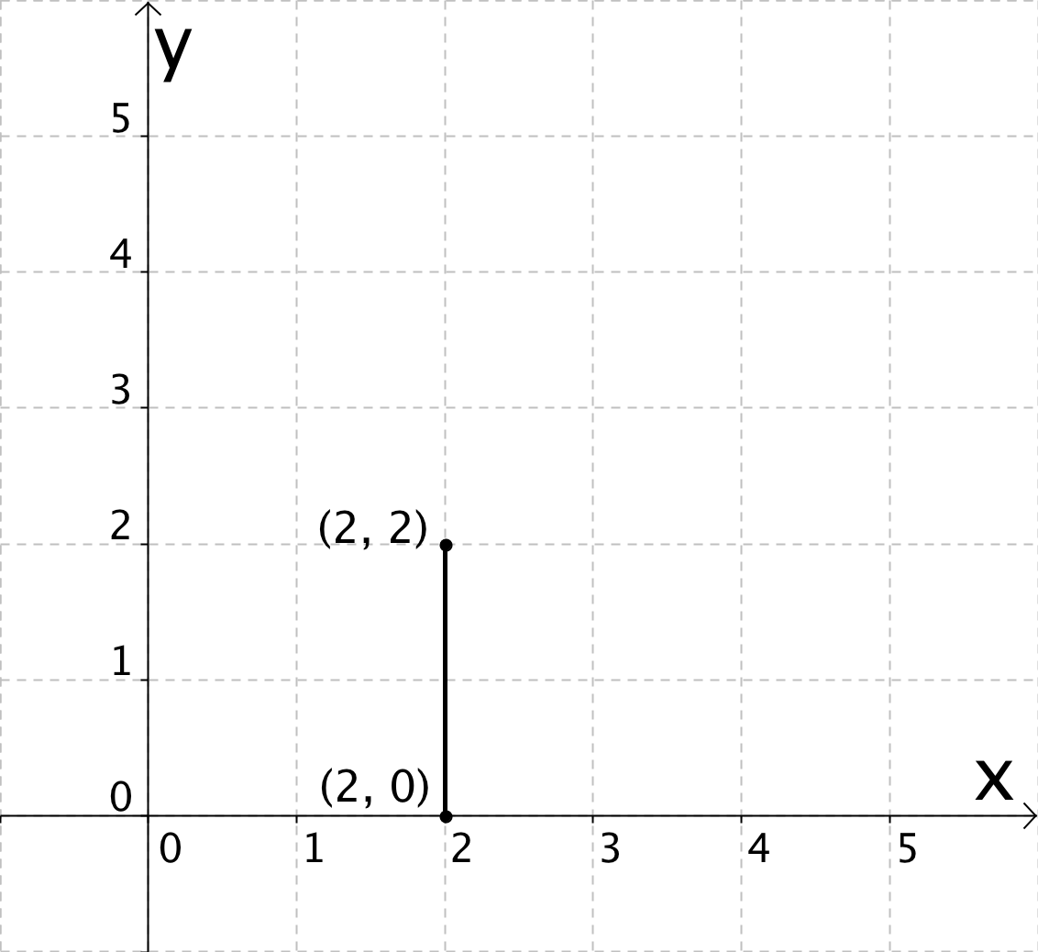

Questions:

1. What coordinate stays the same in each of the three examples?

2. What coordinate changes in each of the three examples?

3. What is the relationship between the coordinate that changes and the length of the line segment?

Summary:

Another way to measure a horizontal or vertical line segment is by…

A Polygon Example:

Using ONLY the coordinates of the vertices, find each side length. Next to each side show the calculation you used to find the length.

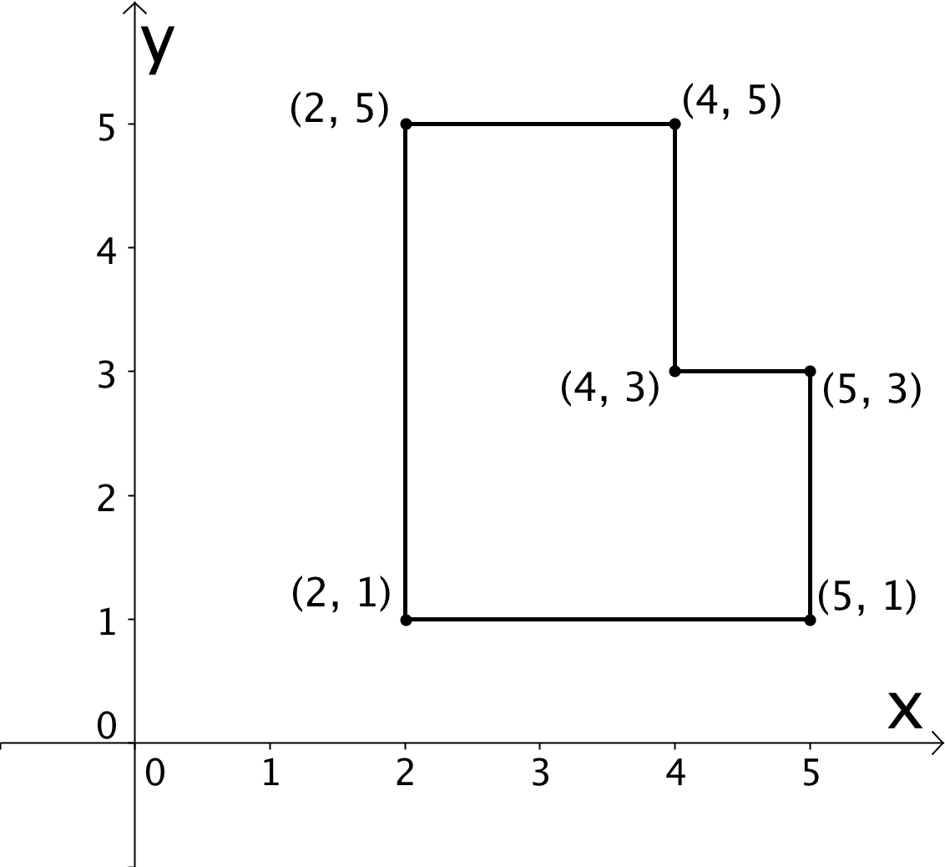

Plotting Polygons 6G3 Lesson 3: Launch (Answer Key)

Measuring Horizontal Line Segments:

Method #1: Counting on the Coordinate Plane | Method #2 | Check
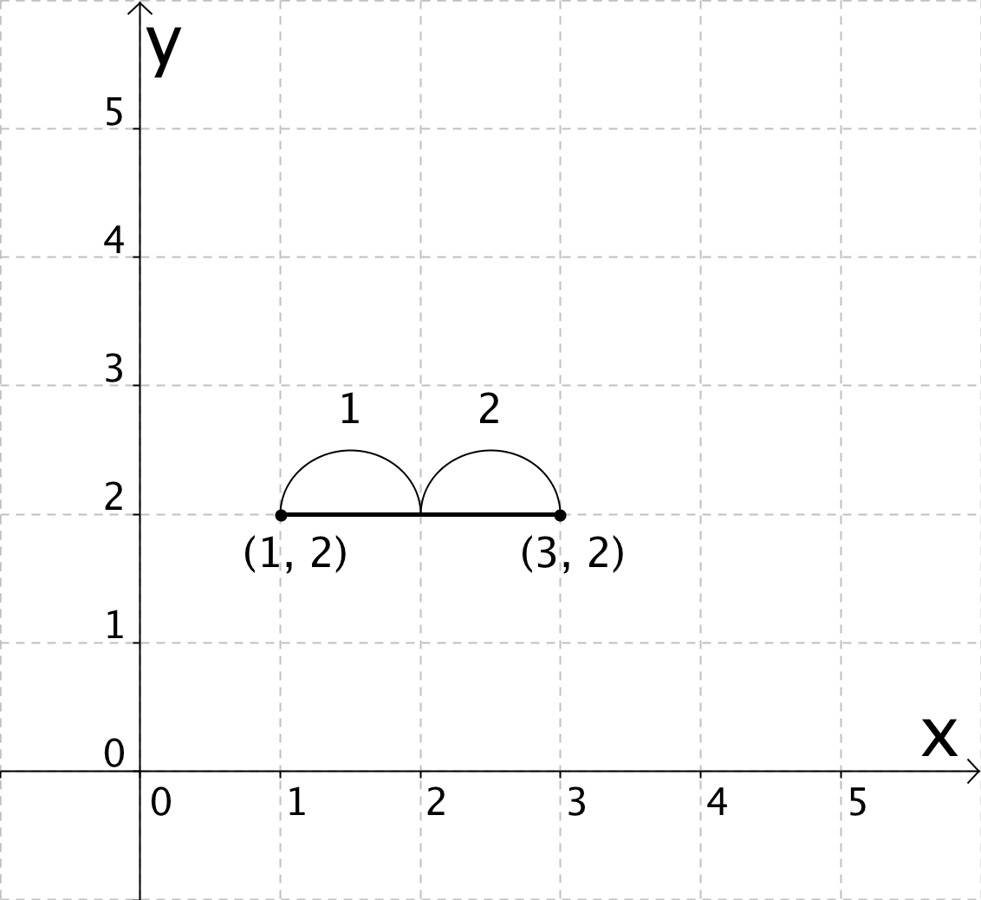 2 units | 3 – 1 = 2 units
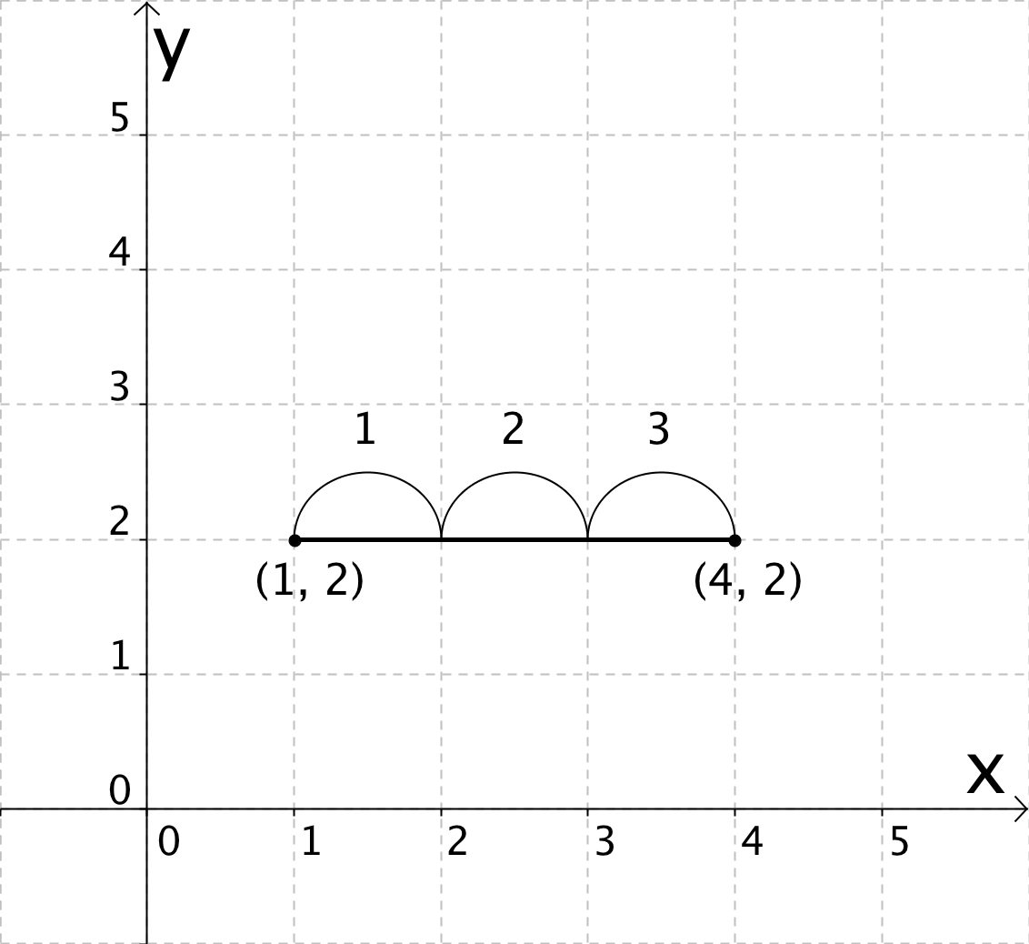 3 units | 4 – 1 = 3 units
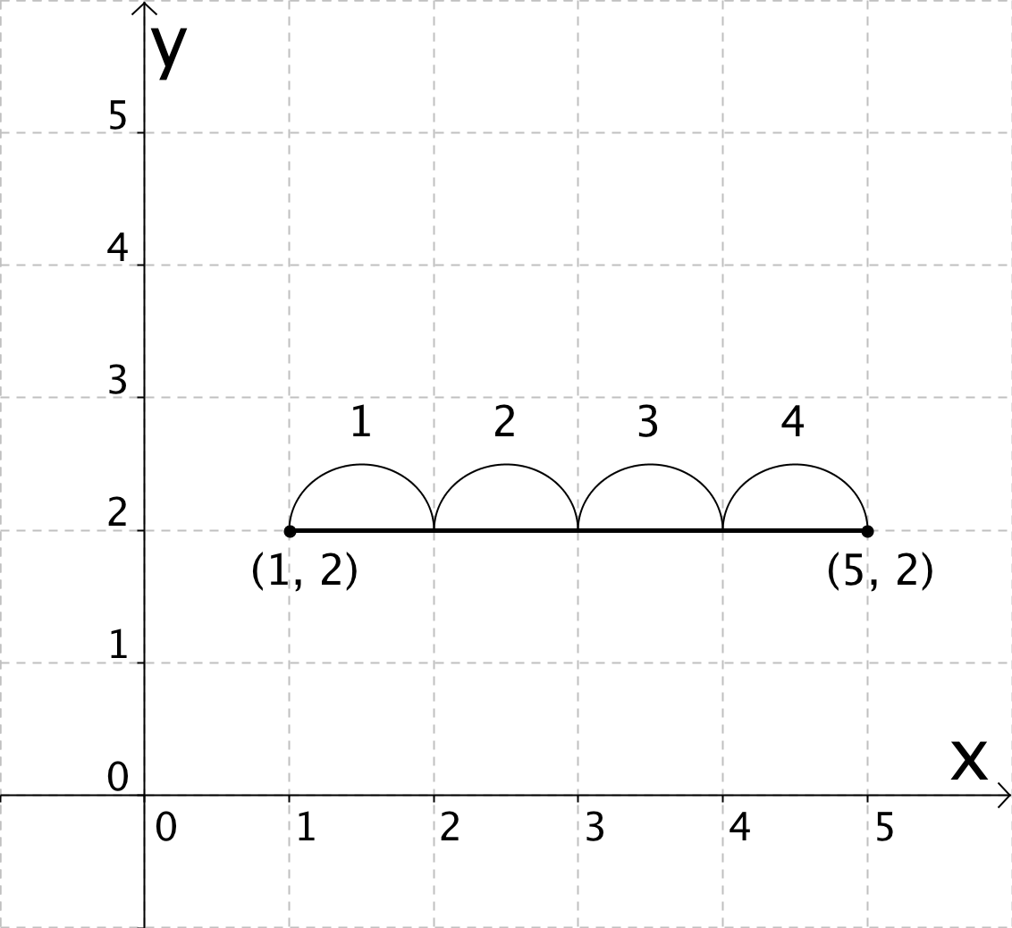 4 units | 5 – 1 = 4 units

Questions:

1. What coordinate stays the same in each of the three examples?

The y-coordinate was the same in each example.

2. What coordinate changes in each of the three examples?

The x-coordinate changed in each example.

3. What is the relationship between the coordinate that changes and the length of the line segment?

If you subtract the coordinates the smaller x-coordinate from the larger one you get the length of the line segment.
Measuring Vertical Line Segments:

Method #1: Counting on the Coordinate Plane | Method #2 | Check
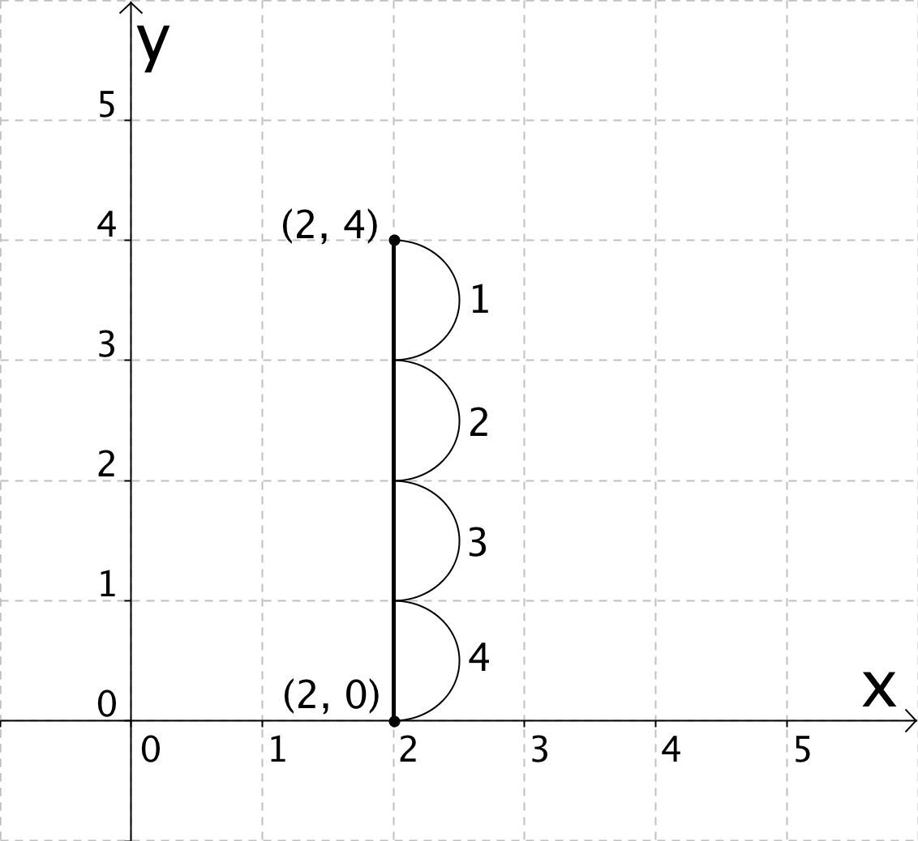 4 units | 4 – 0 = 4 units
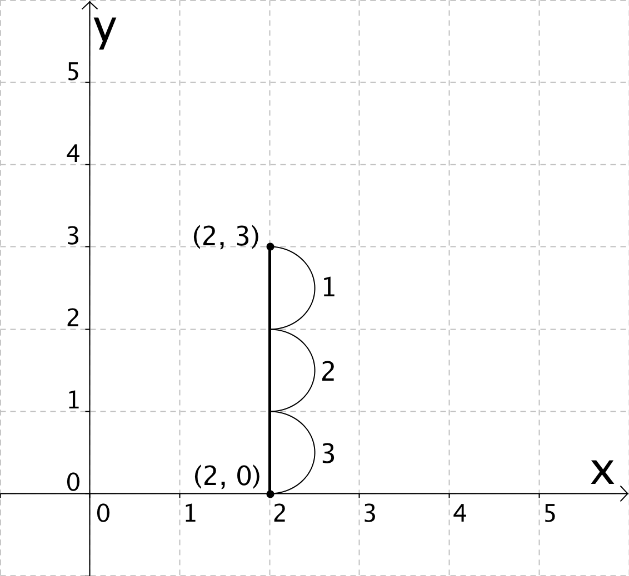 3 units | 3 – 0 = 3 units
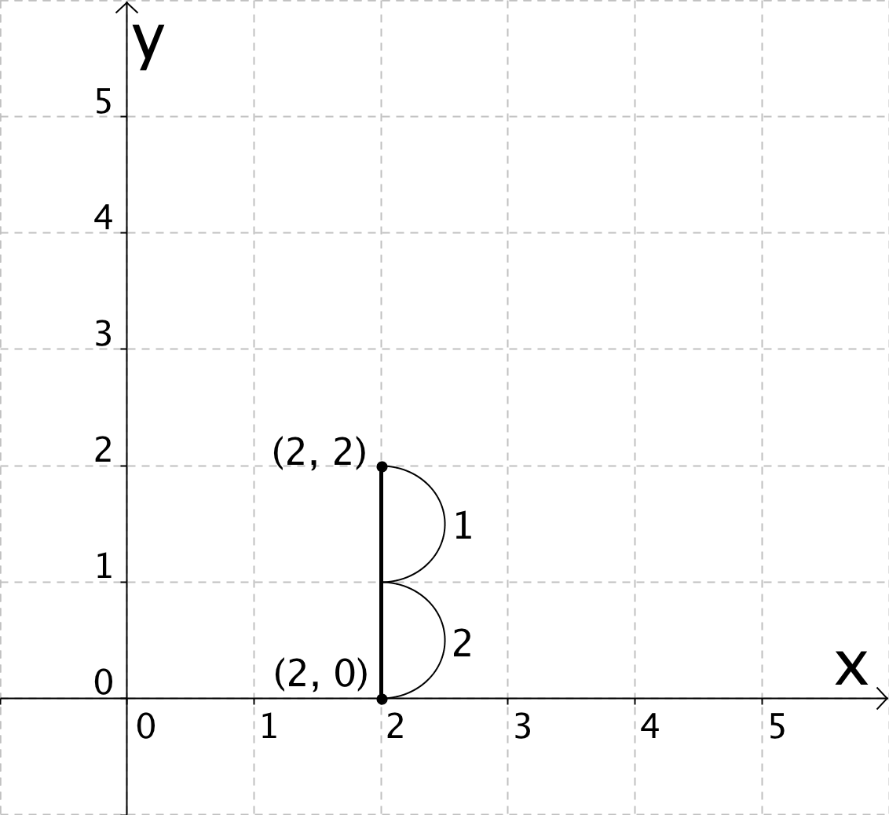 2 units | 2 – 0 = 2 units

Questions:

1. What coordinate stays the same in each of the three examples?

The x-coordinate was the same in each example.

2. What coordinate changes in each of the three examples?

The y-coordinate changed in each example.

3. What is the relationship between the coordinate that changes and the length of the line segment?

If you subtract the coordinates the smaller y-coordinate from the larger one you get the length of the line segment.

Summary:

Instead of counting, another way to measure a horizontal or vertical line segment is by…

…subtract the smaller coordinate that changes from the bigger coordinate that changes between the two endpoints of a line segment (or polygon side).

We can call this Method #2: Calculating Using Coordinates

Polygon Example #1:

Using ONLY the coordinates of the vertices, find each side length. Next to each side show the calculation you used to find the length.

