Business Items  (10 minutes) | Step 1 - Spiral Review  Complete the daily Spiral Review problems and be sure that you include your work. |  | Step 2 - Warm Up  Process the Error Analysis question independently. Talk to your shoulder partner about the misconception and what the correct answer should be. |  |  |  |  | Step 3 - Math Talks – Homework Discussion  Use the answer keys, if provided, to check your homework. With your shoulder partner, discuss the problem(s) that you still don’t grasp.
Review  (10 minutes) | Prerequisite Skills  You 10 minutes to review any of the skills required to plot polygons on a coordinate plane. | Skill #1 – Plot Points  Watch the Khan Academy video for a quick refresher. |  |  |  | Skill #2 – Distance Between Points  Try these Khan Academy practice problems to help you find the distance between two points on a coordinate plane. |  |  | Skill #3 – Area  Visit this online tutorial site for help finding the area of any polygon.
Lesson  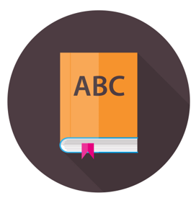  (20 minutes) | Coaching Points/Update Note Guide  - Can you plot points to make a polygon?  - Can you find the length and width?  - Can you find the perimeter of the polygon?  - Can you find the area of the polygon?  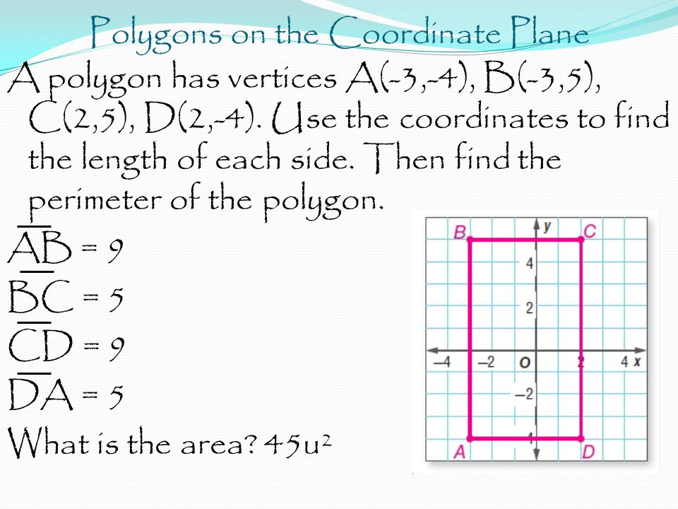 |  |  |  | Free Choice | Choice 1 – Watch this YouTube video to see how to plot polygons on a coordinate plane. |  |  | Choice 2 –. Watch this YouTube video to see how to find the length of a side of a polygon on a coordinate plane.
 |  |  |  |  |  | Choice 3 – Watch this YouTube video to the area of a parallelogram on a coordinate plane. |  |  | Choice 4 – Watch this YouTube video to see how to find the area and perimeter of a polygon on a coordinate plane.
Practice  (15-20 minutes) | Classwork  Open up the attached document to gain access to the classwork problems of the day. You will need to recall previously taught lesson on plotting ordered pairs, distance between points, area, and perimeter to be able to answer these problems. You will be allowed to work in small groups but you must agree on the answer before moving on to the next problem. Good luck!
HW | Homework  Click on the document link to open up the homework assignment on polygons and the coordinate plane. Be sure to check your answers using the answer key before coming to class.
Remediation | Let Your Data Drive Your Decisions  Rate your level of understanding with polygons of the coordinate plane. If you feel weak at all, select a remediation tool from the choices provided. The additional help will pay off, as you work towards content mastery. |  |  | Free Choice | Choice A – Khan Academy Practice  Get some extra practice drawing polygons on a coordinate plane with Khan Academy. |  | Choice B – Math Arcade  Play the Homer Simpson game to remediate how to plot points on a coordinate plane. |  |  | Choice C – Math Arcade  Play this game for additional help plotting points on a coordinate plane.
 |  |  |  |  | Choice D –Math Arcade  Play this game for additional practice finding the distance between points on a coordinate plane. |  | Choice E – Quizizz  Visit Quizizz and search for games by “mmcdowel” to find the game titled “6.G.3 Find area and perimeter on the coordinate plane”.  . |  |  | Choice F – Help Desk  Check in with the teacher for some quick, low key help. Be sure to bring some work samples to share. This will allow for a quick diagnosis.

