**Perimeter and Algebraic Equations**

Disco Stu loves to throw shapes on the dance floor. Using your knowledge of shapes and algebra, find the perimeters of these:

3a

3a

2b

2b

2c

2c

h

h

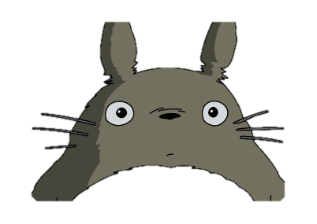

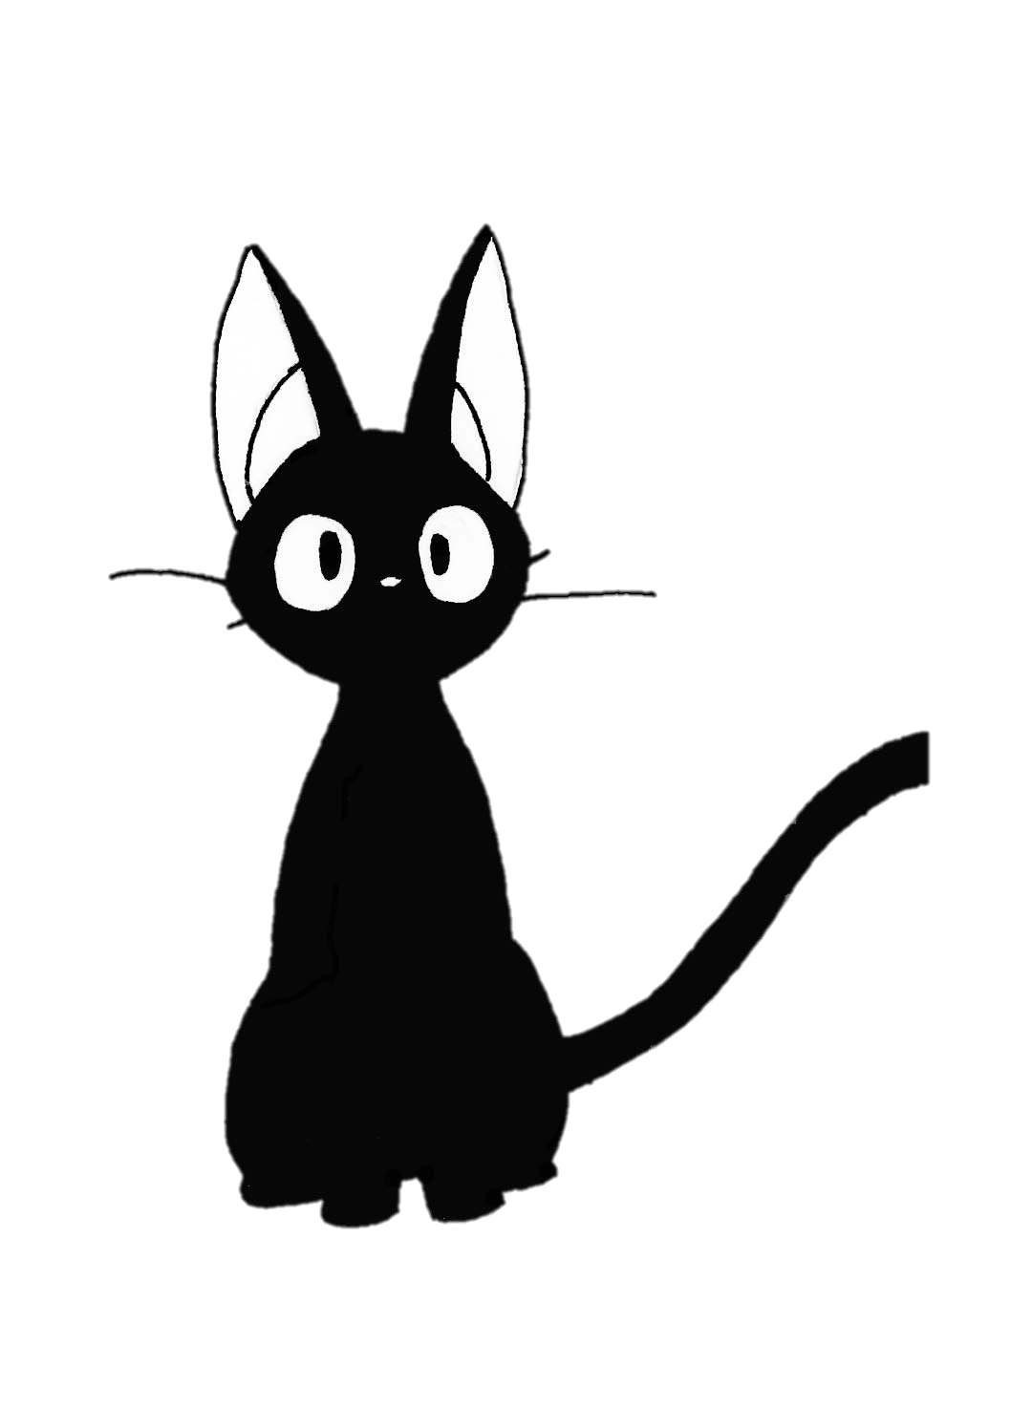

2f

2f

2y

2y

9m

9m

9m

9m

3w

3w

6w

7y

3y

4y

5k

4k

3d

3d

3f

3f

2f

11c

5c

7p

7p

9b

9b

7t

3d

2k

2d

6n

6n

3p

3p