Find the area of the shaded region in at least two different ways:

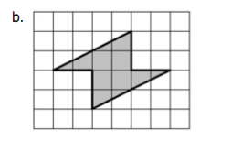

Explain, or show, the two different ways here:

