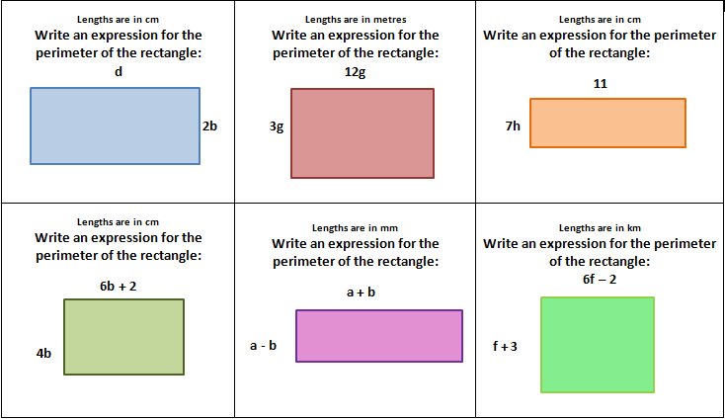

Work Space:
Perimeter -  Area – | Perimeter -  Area – | Perimeter -  Area –
Perimeter -  Area – | Perimeter -  Area – | Perimeter -  Area –

