To answer the following, you may either use formulas and arithmetic or grid paper. But you must show your work to show how you solved the problem.

A Giraffe Ranch
The diagram below shows the parcel of land on which Aristotle the rancher confines his giraffes.
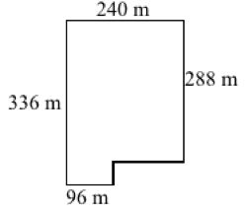
What is the area of this parcel?

Extension: If each giraffe requires 500 square meters of space, approximately how many giraffes can the parcel accommodate?

