Business Items  (10 minutes) | Step 1 - Spiral Review  Complete the daily Spiral Review problems and be sure that you include your work. | Step 2 - Warm Up  Process the Error Analysis question independently. Talk to your shoulder partner about the misconception and what the correct answer should be. |  |  |  |  |  | Step 3 - Math Talks – Homework Discussion  Use the answer keys, if provided, to check your homework. With your shoulder partner, discuss the problem(s) that you still don’t grasp.
Engage  (10 minutes) | Math Talks 2.0  Can you find the area of the irregular polygon on the coordinate plane? Turn to your should partner and take turns explaining what you would do.
Lesson  (20 minutes) | Coaching Points/Update Note Guide  Option #1 - Decompose the irregular polygon into rectangles, triangles, parallelograms or trapezoids and find the areas of each shape by adding them together  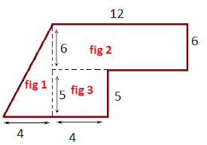  Option #2 - Find the big area and subtract the small area to find the area of the irregular polygon  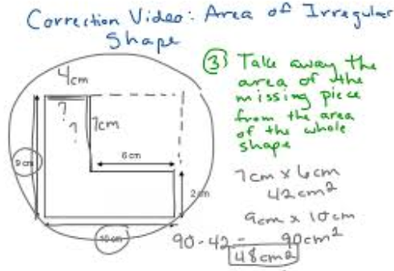 |  |  | Free Choice | Choice 1 – Watch this Khan Academy video for finding the area of irregular polygons. |  |  |  | Choice 2 – Test yourself with these 9 interactive practice problems from algebra4children.
 |  |  |  |  | Choice 3 – Watch this video for examples on finding the area of irregular polygons using both strategies. |  |  |  | Choice 4 – Practice finding the area of irregular polygons with Discovery Ed’s Polygon Composes/Decomposer Math Interactive.
Practice  (15-20 minutes) | Classwork #1:  With you shoulder partner, open the document and find the area of Jim’s bedroom two different ways. Be prepared to share out with the class. |  |  |  |  | Classwork #2:  In teams of two, open the document and determine two different ways to calculate the area of Cindy’s TV room. Be prepared to share out with the class.
HW | Homework #1:  Solve the 15 homework problems by decomposing the irregular polygons into shapes that you are comfortable finding the area for. |  |  |  |  | Homework #2:  Solve the 11 homework problems to solve the riddle of “Why Do Elephants Have Ivory Tusks?”
Remediation | Let Your Data Drive Your Decisions  Rate your level of understanding with finding the area of irregular polygons. If you feel weak at all, select a remediation tool from the choices provided. The additional help will pay off, as you work towards content mastery. |  | Free Choice | Choice A – Discovery Ed  Get additional practice with the decomposing/composing method using Discovery Ed’s Area Architect 2. |  |  | Choice B – Video  Watch the Khan Academy video where the area of the irregular polygon is drawn on graph paper. |  |  | Choice C – Shodor  Find the area of irregular polygons with Shodor’s Area Explorer.
 |  |  |  | Choice D – Interactive Lesson  Check out this interactive lesson from learnalberta. Feel free to fast forward through the lesson material on perimeter. |  |  | Choice E – Splash Math Game  Find the area of complex figures on Splash Math. |  |  | Choice F – Help Desk  Check in with the teacher for some quick, low key help. Be sure to bring some work samples to share. This will allow for a quick diagnosis.

